A Visit to Burnaby Village Museum
Dear Families,
Division 11 and 5 will be walking to Burnaby Village Museum on Friday, December 15th, 2023. This is a free walking field trip. We will have a regular school schedule in the morning. After the classes have finished their lunches at 12:20pm, the Buddy classes will walk together down Buckingham Avenue to the museum.
While we are there, we will do the scavenger hunt and enjoy the sights and sounds of the holiday festivities. We plan to return to the school by 3:00pm for regular dismissal. We are hoping to have a few parent volunteers who are comfortable supporting small groups of children as they explore the museum outside. Please let us know if you are available to help or if you do not wish your child to participate by writing a message in your child’s planner. If you do not want your child to come, we will find an alternative activity at the school for them.
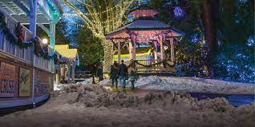
Thank you,
Mrs. Klassen & Ms. Wong

