Day 3:
Wednesday, June 3rd

Morning Work
Today, we will be talking about solids, liquids, and gases and building molecule models for each of the types

- We will start off by watching this video to build on our knowledge of the properties of each state and name some examples
https://www.youtube.com/watch?v=MrTxRn9MNWM

- 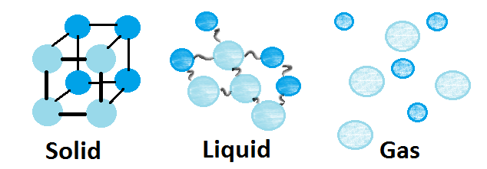

Your work right now will be to build a model of the molecules of each of these states out of any material you have available to you – Lego, toothpicks, sticks, leaves, rocks, etc.
(it would be cool to use mini marshmallows ) Send a picture to Showbie!

Afternoon Work: Today, we will do a diagnostic to see what you already know about writing instructions. You will have 15 minutes today on the Zoom call to write directions for how to make a peanut butter and jelly sandwich (sounds random, but it will make sense later)

Then, we will watch the video and see who came closest to creating the clearest step-by-step directions.

You will then re-write your step-by-step instructions – you cannot re-watch the video though to copy the final instructions – make your own! Post to Showbie!
https://www.youtube.com/watch?v=Ct-lOOUqmyY

Writing in the imperative mood means to write with command-based language:
- Open the Jar – the word open is very clear and commands you to do something, it usually starts as the first word in the step.

