Welcome to Day 20 of Online Learning - Wednesday, May 6th, 2020
Good morning!

Morning Work:
There is no in-class session on Zoom in the morning today because Ms. Wilks has a meeting. There will be one in the afternoon as usual.
Math: Today, we will be talking about creating tally charts for our surveys. Our unit project will be to create a tally chart and various types of graphs to show our information and data collected. Where have you seen a tally chart before in our classroom?

Remember that with a tally chart, we group the tallies into groups of 5. The fifth lines goes diagonally across to make a group, so it is easy to count the numbers.

Tally Chart Maker - https://www.meta-chart.com/tally#/your-charts

Today, you are going to use a tally chart to collect your own data. You will be rolling the online dice or ten dice that you have and record how many of each number appear in each roll. You will have 10 trials, which means that you will roll the dice 10 times.

You can hand write it or use the chart below:

Dice Numbers | 1 | 2 | 3 | 4 | 5 | 6
Trial 1 (Roll 1)
Trial 2
Trial 3
Trial 4
Trial 5
Trial 6
Trial 7
Trial 8
Trial 9
Trial 10
Total Number of Tallies

For example: When I rolled the dice online, these numbers came up for my first roll (also known as trial 1) – Trials are just each time you roll all 10 dice at once.
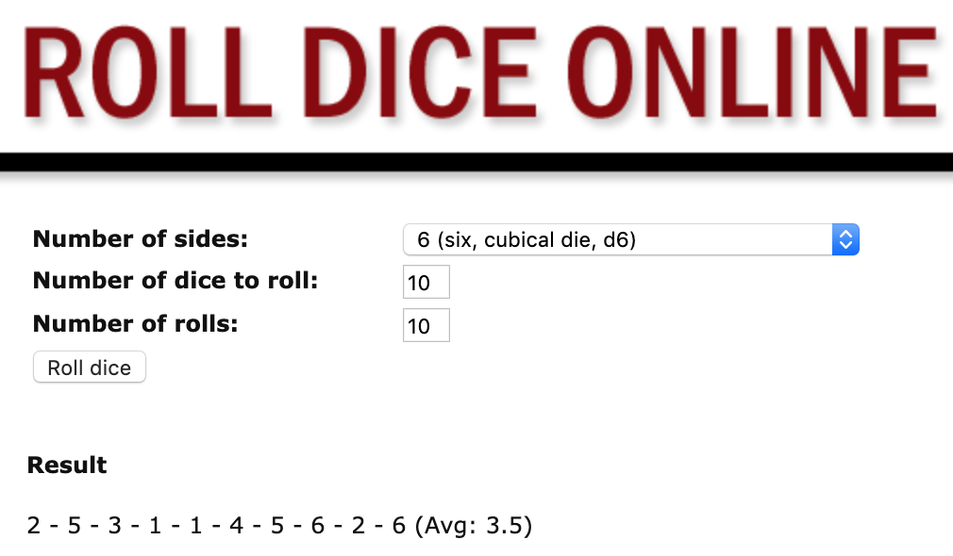

Dice Numbers | 1 | 2 | 3 | 4 | 5 | 6
Trial 1 (Roll 1) | ll | ll | l | l | ll | ll
Keep in mind that if you have five or more of one number it would look like this:

llll llll = 10 – it is easily grouped into two groups of five so it is easy to count and visibly see.

Complete the chart (http://www.roll-dice-online.com/ to roll dice – look at my settings above to roll 10 dice, ten times and hand into Showbie.

Afternoon Work:

Literacy: continue writing descending action & conclusion, Rough draft is due on Monday for editing by Ms. Wilks.

Spelling Test Tomorrow! (Thursday, May 7th)
Please also study for your spelling test tomorrow! The link is: https://www.surveymonkey.com/r/5K3KGCL
Please have it pre-loaded and ready to go before 9:00 a.m. tomorrow and be on time.

AS WELL, SUPER IMPORTANT!
Afternoon Zoom sessions are cancelled all next week because I am setting up one-on-one Zoom times to meet with students to conduct Term 3 reading assessments for report cards. Please sign up using this Doodle Poll Link – it is first come, first serve so when you see this, please sign up! Please sign up before 3 p.m. on Sunday.

Link:
https://doodle.com/meetme/qc/i3ofqet4Np

Hand in to Showbie
- Tally Chart
- Rough draft of story due by Monday morning (must be at least two pages single spaced and normal sized font 12)

