Welcome to Day 33 of Online Learning - Tuesday, May 26th, 2020
Morning Work:
Today, we will do Lesson 4 in the textbook. We will create a pictograph and a bar graph in class and compare them. We will look at different characteristics between bar graphs and pictographs and create a bar graph and a pictograph for the same data from a tally chart. We will compare and discuss the different parts and assess which one we like better in order to analyze data.
Homework is pages 267-269, all questions.

Afternoon Work:
Today, you will be working with positive and negative artwork again. You will be using a tree and its background landscape. However, you can make the background anything that you want – you could do different seasons, make a galaxy, etc. You could also make the tree the negative artwork as well as seen in the second drawing or you could make it the positive part of the artwork as seen I the first picture. Get creative with it! All that is required is the presence of the tree and the background.

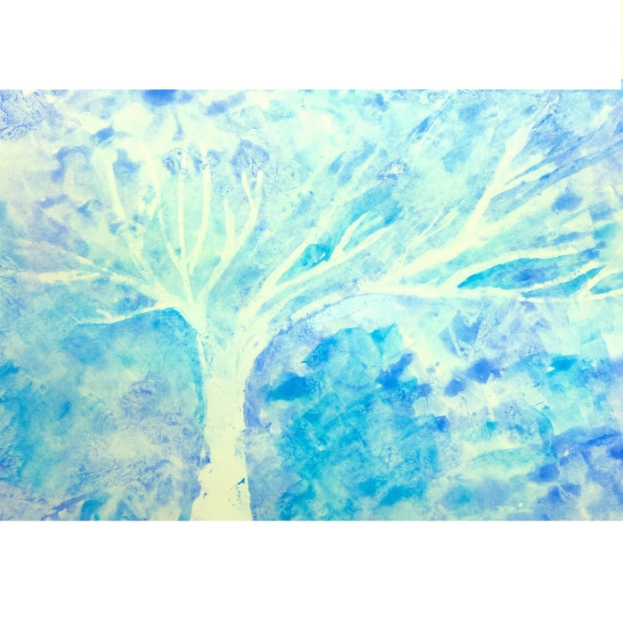

Submit to Showbie
- Math Textbook Work
- Positive/Negative Tree Landscape Artwork

