Welcome to Day 18 of Online Learning - Monday, May 4th, 2020

Good morning, everybody!

Morning Work:
Math: Today, we are going to be starting our Surveys, Graphing, and Probability unit! This is a great unit and we are going to have fun learning about our classmates and their opinions on different subjects.

Today, we are going to learn about the important parts of a graph.

This is an example of a bar graph.

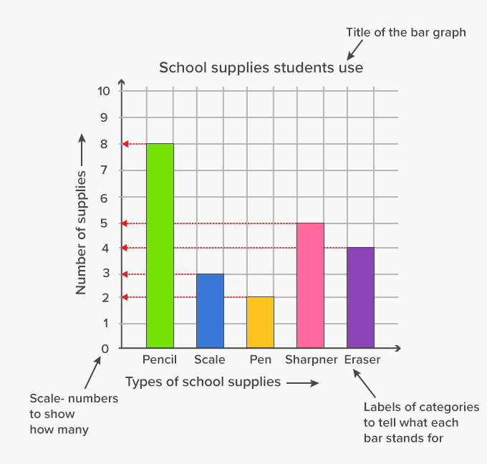

Note the different parts of the graph above.

Your bar graph needs to have:
- A title – you titled needs to have upper case letters at the start of each word and be related to your survey question (what are you asking people and what is your data based on?)
- There must be spaces in between your bars. Notice that there are no bars touching each other and the first bar is not touching the vertical line (axis)
- There is an ‘x’ and ‘y’ axis (lines)
  - The x-axis is the horizontal line: this axis provides you with the options/choices people have to answer the survey question
  - The y-axis is the vertical lines: this axis provides you with information on the number of people that voted for each choice
  - They each have labels – the x-axis has the label: types of school supplies
  - The y-axis has the label: number of people and has numbers at each line of the grid paper – this is the scale with numbers
  - When you line up the bars, you can see which line they correspond with – how many people answered a certain way

Here is an example of a Pictograph:

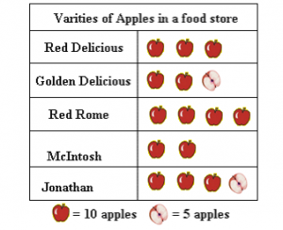

It is called a pictograph because it uses pictures to show data. Your picture that you use to symbolize the amount of people, should be related to your survey topic. For example, if you are asking people what their favourite ice cream flavour is, maybe your symbol/picture should be an ice cream cone.

Your pictograph must have:
- A Title (similar to the bar graph)
- Labels of different options
- Pictures that represent the number of people who chose that option/the number of objects present
- LEGEND – the legend shows how many each picture represents. In this one, how many does one apple represent? How much does a half apple represent?
- What does this pictograph show us?

Please complete the two worksheets on bar graphs and pictographs and submit to Showbie.

Submit to Showbie
- Bar Graph Worksheet
- Pictograph Worksheet

Afternoon Work:
In our Zoom chat, we will share how our story writing process is going and I will check in with students.

Please continue writing your story – you should be working on your rough copy and should be finishing writing the climax (problem/exciting part of your story) and start writing the descending action leading up to a solution.

Very excited to read your stories when they are all done and to read your rough copies

Submit to Showbie
- Your writing progress

