Welcome to Day 23 of Online Learning - Monday, May 11th, 2020
Good morning everybody! Just a reminder that there will be no afternoon sessions this week. Please attend your reading assessment one-on-one session with me. Be on time and be ready to read! Just try your best, that’s all I will ever ask for I will be providing work for you still to do in the afternoon, just use the guide to direct yourself independently.

For reading assessments – use our normal Zoom link.

Morning Work:
This morning, we will be working on exploring charts and making pictographs in Lesson 2 of the textbook.

First, I am going to use this website: https://www.random.org/playing-cards/ to pick a random card. I will fill in this chart: (Pick a random card using the generator 30 times)

Black Card | Red Card
(use tally marks here) | (use tally marks here)
Total: (use number) | (use number)

We can then use this information to make a pictograph.

We will also try making a pictograph by asking a different kind of question to the class about how students travel to school. This is an example from the textbook as well:

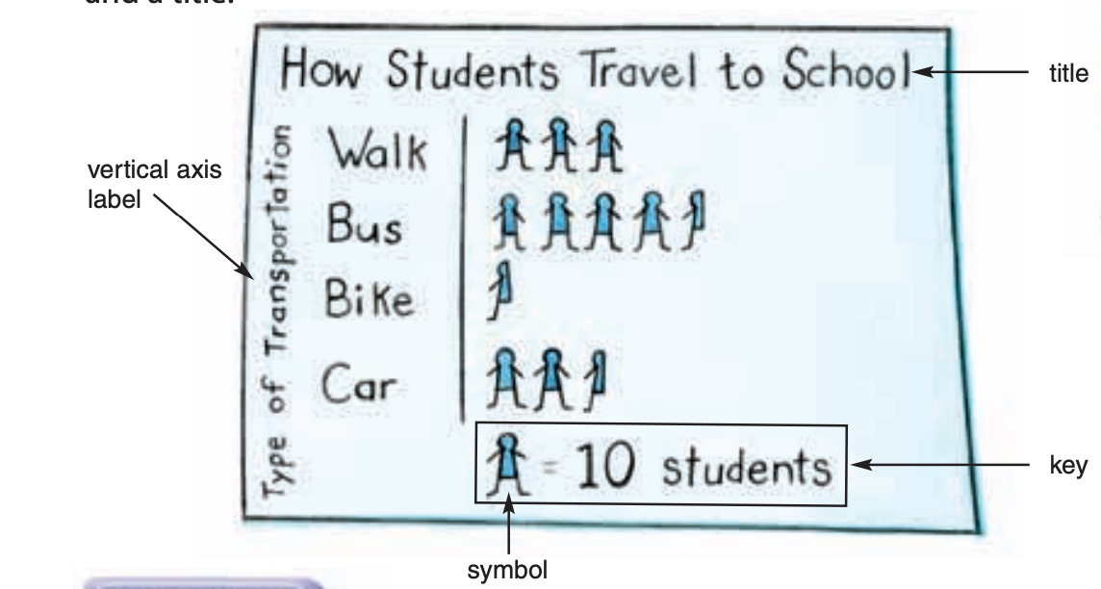

When picking your key/scale, in a pictograph this means the value of your symbol or how much each symbol is worth. In this diagram, one full person means 10 people. How much does a half person mean? You need to pick your key based on your information. If one of your answers has 100 people, it doesn’t make sense to pick 1 as your scale, you might want to go up by 20 as your scale or 50, etc. You need to pick a scale that makes sense for your data and depending on how many people you ask. Again, notice the parts of the pictograph. Another word for the scale as part of a pictograph is the key, so when it asks you this in question one, they mean how much would each symbol be worth?

Also, notice how the symbol matches the topic. The question asked about students, so they used a picture of a student as their picture. Notice, that they are congruent.

Do not forget to include in your pictographs:
-labels (vertical axis label & title)
-options
-key (how much is each symbol worth)
-each of your symbols has to be the same colour, same size, and same picture!

Please complete textbook pages 260-261, all of the questions and submit to Showbie!

Afternoon Work: Remember, there are no afternoon meetings this week, you are working on this independently and uploading to Showbie if there is work to be uploaded.

Task 1: Complete some form of physical activity – Youtube video, Just Dance, yoga, Go Noodle, go for a walk, etc.

Task 2: Draw the title page for your story – you can do this on paper or on the computer. I will be doing a tutorial of book creator in the future, so just sort of start planning out your cover if you will not be hand-drawing it in the final copy.

Submit to Showbie
- Title Page (In Story Writing Folder)

