Welcome to Day 3 of Online Learning - Wednesday, April 8th, 2020

Good Morning!

Morning Work:

We will play this Kahoot in the morning as a class, but feel free to play it on your own too

https://kahoot.it/challenge/0262597?challenge-id=ef8c4814-cce9-4367-abb1-ad6a32cafbc5_1586291097602
Challenge Code: 0262597

Math: Lesson 6.2 (page 228, Complete All Questions)

Today, we will focus on modeling shapes out of modeling clay. If you do not have modeling clay or playdough, think about what else you could use to model 3D shapes. This could include LEGO, random odds and ends used as building materials, cutting and gluing cardboard – have fun with it! You’re at home and there are so many different materials you can use

A new vocabulary word – congruent. When two shapes are congruent, that means that they are equal in size and shape (also known as – they are the same in all attributes and characteristics even if they are rotated/in a different position.
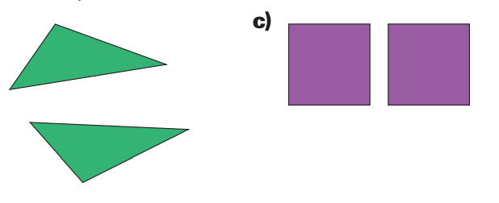
For example:
The two triangles are congruent because if you turn one of the triangles around, they still have the same size and shape. The squares are a bit more obvious because they are obviously the same size and shape and easy to see because they are in the same position. Congruent shapes do not have to be in the same position.

The questions on page 228 will allow you to explore creating shapes when given the different faces. Step 1 – construct each face as specified/shown, Step 2 – put them all together to make a shape!

Afternoon Work:
Literacy:
Today, try to read for 20 minutes by yourself and 20 minutes with a parent or sibling or get creative and see if you can video chat reading to a friend or classmate. Find a cozy place to read in your home

Today for your stories, I want you to create two supporting characters. Supporting characters are background or side characters. They might be friends of the hero or other people who have a different storyline or purpose in your story. Please complete and submit to Showbie.

Health:
Canada’s Food Guide has evolved and changed with more and more information. Go over to the Canada’s Food Guide website: https://food-guide.canada.ca/en/?wbdisable=true and look at the new Canada’s Food Guide.

Answer the following questions:
- How much of your plate should be fruits and vegetables? How much of your plate should be protein? How much of your plate should be whole grains?
- What are some examples of each of these categories? – Fruits & Vegetables, Protein, and Whole Grains
- Go to this website: https://standingstrongwellness.com/2017/07/15/canada-food-guide-is-under-review-positive-changes-coming/
-There is a picture of the food guide before it was changed in recent years. What do you notice is different about the old food guide vs. the new one you looked at on the Food Guide Canada website at the start of this lesson? What do you think of these changes? Write a paragraphs (at least 5 sentences) to discuss your answers.

Challenge: See if you can challenge yourself for the week to make some health conscious choices in eating. Try to fill up your plate according to the new Food Guide. Healthy eating is very important for your brain, muscles, bones, and for energy in order to partake in many different activities!

Submit to Showbie
- Completed Math textbook work
- Two Supporting Character sheets (submit to Story Writing Folder on Showbie)
- Health Questions Completed

