Welcome to Day 6 of Online Learning - Wednesday, April 15th, 2020

Good morning everybody

Morning Work:

Math: Introduction to Symmetry:

Today, we are going to explore a number of games in order to learn about symmetry! Symmetry is one of my favourite topics. It means that using a dividing line (line of symmetry) placed on a shape, that if folded on that line, the shape will fit perfectly on top of itself – both shapes will be congruent since they are the same shape and same size. The dividing line is called a line of symmetry.

Can you find a line of symmetry on each of these shapes?

Possible Answers: There can be multiple (more than one) lines of symmetry on each shape! Try to fold these shapes in your head on the lines, you’ll see that the lines divide the shape up into two congruent shapes! You can test by cutting out the shapes on paper and folding them, if they fold and line up perfectly, you have a line of symmetry!

4 lines of symmetry 3 lines of symmetry 2 lines of symmetry

Practice Challenge #1: Print out the attached shapes and try folding them and drawing lines of symmetry to see how many you can find. Submit this on Showbie. When in doubt, test it out – fold the shape to check lines of symmetry even if it might seem obvious at first.

Practice Challenge #2: A cool adventure game for symmetry!: https://www.topmarks.co.uk/Flash.aspx?a=activity19

Typing Practice (if you don’t get to this, that’s okay)
Practice on “All the Right Type” – make sure it is the Canadian website, not the US website (it needs to have .ca at the end or it WILL NOT WORK).

- Go to https://www.atrtonline.ca/index.html
- Click, “Login – School User”
- Type in School Code – canbcsd412075
- Enter User ID and Password – I have posted a chart below of the logins.

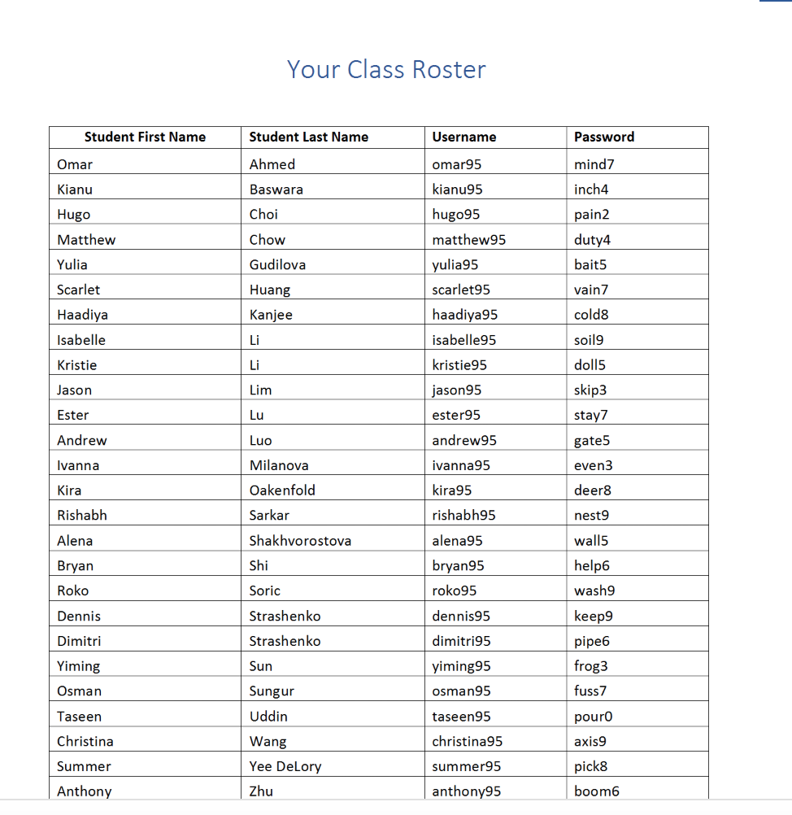

We will also have a second practice session on Kahoot for spelling word definitions in preparation for tomorrow!

Afternoon Work:

Literacy: Please read for 40 minutes today as always.

Working on Quotation Marks and Dialogue!
In almost every story, there is dialogue. Dialogue is when characters are speaking. They can be speaking to themselves, another person, or an animal or other character. When we use quotation marks, there are a lot of rules.

Today, we will practice the basics of using quotation marks.
These:
“ = opening quotation marks
” = closing quotation marks

Notice how the quotation marks are curved toward where the words are. Opening quotation marks come before the words said and closing quotation marks come after the words are said. Today, we will just look at people talking a normal sentence that ends in a period. For example:

I told you to stop doing that so you wouldn’t get hurt said her mother.

When you have a sentence like this, you need to put opening quotations at the start of the words and closing quotations at the end of the speaking part. So the quotations would look like this:

“I told you to stop doing that so you wouldn’t get hurt” said her mother.
-said the mother is not in quotations because no one is saying that part out loud. But we’re not done!

In a sentence that ends in a period, we need to add a comma right before the closing quotation marks:

“I told you to stop doing that so you wouldn’t get hurt,” said her mother.

There, we’re all done

Another example: if the said part comes before, you need to add a comma before the opening quotations. Think of it as separating the two parts – one is just stating WHO is saying something but not saying anything, and then adding a comma to separate it from the actual speaking part.

His mother said to Kurt Thomas is going to come over today.

Becomes…..

His mother said to Kurt, “Thomas is going to come over today.”

The period stays within the quotation marks.

Practice the worksheet attached as you will need to know how to use quotation marks in your stories!

Art:
Make a model of your favourite animal out of clay, playdough, or any other material in your house, be creative and share the picture with me!

Our spelling test is tomorrow at 12:30 p.m. Make sure you are on the Zoom call ready to go! There will be no morning session tomorrow as I have a staff meeting, so we will just meet in the afternoon – try to read through the guide and complete the morning work.

Submit to Showbie
- Draw lines of symmetry on shapes & Practice Folding the Shapes into symmetrical parts
- Picture of model of your favourite animal (can be origami if you want)

