Welcome to Day 4 of Online Learning - Thursday, April 9th, 2020

Good morning, everybody

Morning Work:
Math: Today is all about creating and exploring nets. A net of a shape is a layout of 2D shapes connected together that when folded together creates a 3D shape.

https://www.geogebra.org/m/pCv2EvwD
Try this game on creating nets!

For example: This is a net of a cube. We can test it by cutting along the outside edges of the shape and folding it up. This net is made up of six 2D shapes that are all congruent (same size, same shape) squares.

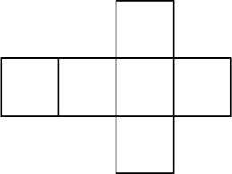
Challenge 1: How many different kinds of nets can you make that form a cube? Hint: There are 10 other nets + the one above (11 nets in total). Try to draw them out on a piece of grid/blank paper. Test them out to see if they work.

Challenge 2: Explore the various 3D Shapes on this website and matching game: https://www.mathsisfun.com/geometry/common-3d-shapes.html
https://www.math-play.com/3d-shapes-game/3d-shapes-concentration_html5.html

Practice naming the different shapes – the most important ones are: sphere, cylinder, cone, cube, cuboid (rectangular prism as we learned in Lesson 1), triangular pyramid, square pyramid, and triangular prism (also from Lesson 1).

Sphere: it is the round ball-like shape, it has no edges or vertices and one curved face/no flat faces.
Cone: think of an ice cream cone, it has one flat, circle face (where you put the ice cream) and one curved face.
Cylinder: think of a can, it has two flat, circle faces, and one curved face in the middle.
Cuboid/Rectangular Prism: all of the faces are flat face rectangles
Triangular Prism: think of a Toblerone bar, it has two triangle faces and three rectangle faces in the middle, all flat faces
Square Pyramid: the first word in this name tells us what kind of base it has – it has a square base which it stands on and four triangles that join up into a single point/vertex
Triangular Pyramid: the first word in this name tells us that it has a triangle base, and from each side of the base, there is a triangle faces coming from each of the three sides, meeting in a single point/vertex at the top

Go to this website and play around on this net making game https://www.turtlediary.com/game/nets-of-3d-shapes.html
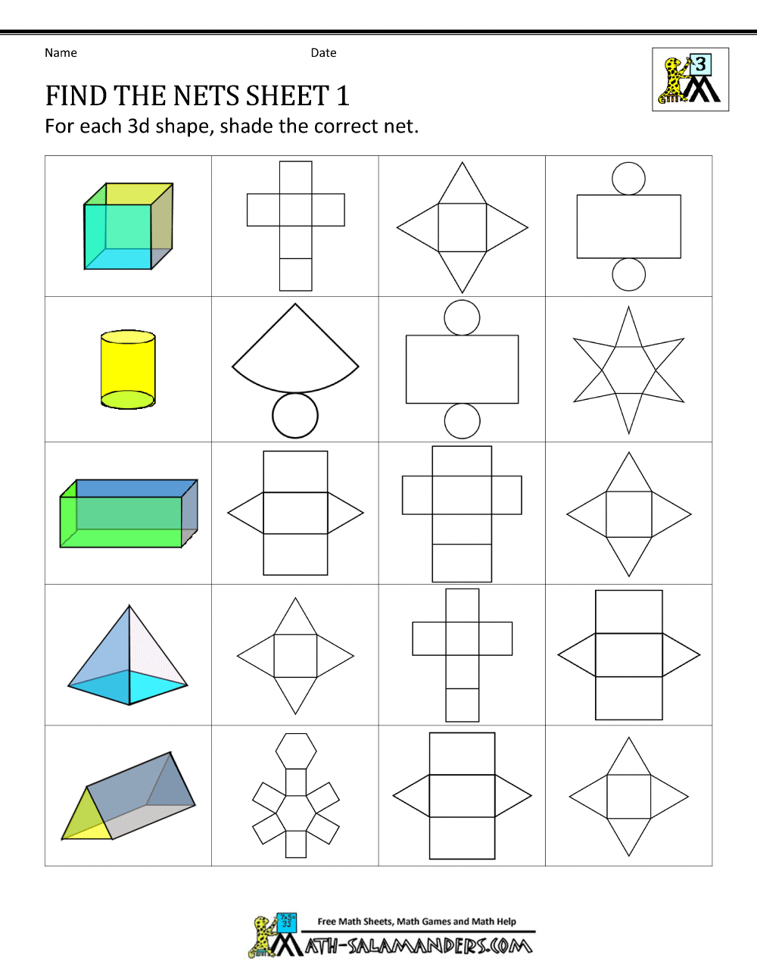
Name each of the shapes above and circle its proper net. If it helps, draw and cut the out and try folding it up to see if it matches or works. Often times, when drawing out nets, we can miss one side easily as it can be difficult to imagine it folding up in our minds.

ADST: Do some Code Combat Remember: your username is: Firstname9tp and password: taylor park

For example: mine would be:
Username: melody9tp
Password: taylor park

Afternoon Work:

Literacy: Make sure to read 40 minutes today!
Please write me one page about the book you are reading right now and what it happening. Thing about your summarization skills and what important parts should be included in your summary so that I know what is going on even if I have not read the book. Remember to write with voice, as Ms. Berto was working on with you. Add your own personality and reactions in your writing, it makes it more interesting!

Science: Herbivores, Carnivores, and Omnivores

Animals are classified (sorted) into the categories of Carnivores, Omnivores, and Herbivores based on what kinds of foods and food sources they access. For example, some humans are omnivores which means that they eat both plant and animal (meat) sources, while some humans are herbivores, which means they only eat plant sources. Carnivores are animals that only eat from meat sources such as eating other animals. As you will learn from the worksheet, different animals have different adaptations. Adaptations are either behaviours or physical characteristics that animals have in order to make survival tasks in their daily lives easier. One physical adaptation that depends on food sources, is the shape and size of an animal’s teeth. Different animals have different teeth depending on whether they eat plants, animals, or both.

Read the worksheet attached and answer the questions to learn more about the adaptations that each different type of animal has.

Have a great long, holiday weekend and I will see you on Tuesday!

For the Weekend
- Please write me a letter on what you are doing for the long weekend (no school on Friday or Monday due to Easter holiday)!

Submit to Showbie (all due Tuesday by 9 a.m.)
- Find the Nets Sheet
- Herbivores, Carnivores, and Omnivores Sheet
- Book Summary
- Letter on Weekend (submit to Weekend Journal Folder on Showbie)

