Welcome to Day 1 of Online Learning - Monday, April 6th, 2020

Below will be a typed out script describing a bit about what you are expected to know for this lesson. The Math Textbook can be searched up online by Googling: Math Makes Sense Grade 4 PDF or pressing this link: http://fc.gsacrd.ab.ca/~Colette_Klemmer/S01483F91-01483F91.2/mms4.pdf

Morning Work:

Math: For our introductory Math lesson to Geometry and shapes, we were simply going to do an exploratory tour and recognize various 3D and 2D shapes that are present in our environments.

On a piece of paper, write and draw 10 different 3D shapes and 10 different 2D shapes that you can see. Walk around your house and backyard if you have one and identify the different kinds of shapes you already know. Being aware of different shapes in our world helps us apply our learning to the construction of different shapes for different usages. For example, how would a television be different if it had a triangular screen or octagonal screen instead of a rectangular screen.

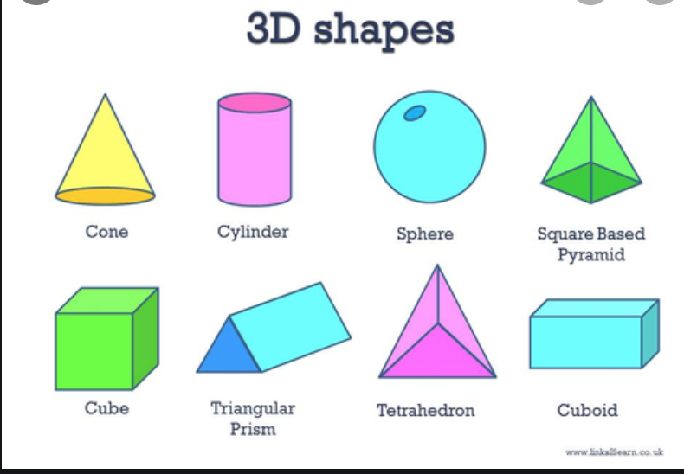

Go conduct your search of these 20 shapes. Record them in a chart like this (make your own chart on a separate piece of paper):

Home Object | Shape (2D or 3D?)
Example: Die | Cube, 3D
Continue this chart for 20 objects.

We can sort different 3D shapes by the 2D shapes they are made of. Do they have square, triangle, rectangle, octagonal, hexagonal faces? How many faces do they have (For example, a die cube has six faces or six sides. We use the word ‘faces’ for 3D shapes even though in common language we might say ‘sides’, this is to avoid confusing the word ‘sides’ used to describe how many lines are used to construct 2D shapes.

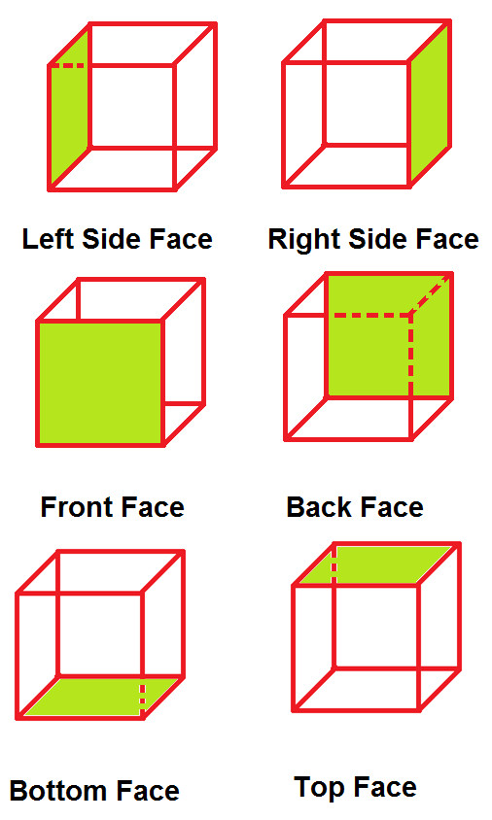
Drama: For Drama, we would have been making fairy tale skits in groups. Since we are not allowed to be in groups, re-read your favourite fairy tale or pick a fairy tale to read.

After you have read it, write ten full sentences to describe:
- Who are the main characters?
- What are the main characters like? What are some adjectives (describing words) to describe them?
- What are the main parts of the story? (think of our Story Mountain: Beginning, Rising Action, Climax (most exciting part), Descending Action, and Solution/End

Afternoon Work:

Literacy:
- Please read for at least 40 minutes every day! (not just comic books, please read novels as well to continue to challenge your brain).
- Suggestions: Rest of the Tales of a Fourth Grade Nothing series, Chronicles of Narnia, Sunwing Series… https://www.goodreads.com/shelf/show/4th-grade-reading-list - some ideas of more classics! I have been borrowing books online from my library account in Vancouver. I assume Burnaby also has the feature for you to borrow to read online. If not, there are usually some copies of books online that you can find in pdf form, buy for Kindle, etc. Epic Books is awesome too – I sent your parents a link by email!

We are starting our story unit! This is an extension from our Indigenous myth unit where we worked on our story mountains. We talked about story plots and how there is a beginning, rising action, climax (the most exciting part of the story, usually when the problem really becomes an issue), descending action, and solution/ending of the story. We will go into further detail in our lesson on plot and setting up our stories.

You can write a story on anything, but before we begin to write, we need to set up all of the elements of our stories. Today, we will focus on main characters. What is a main character? The main character, also known as the protagonist is the person who stars in the story. It can follow their life and adventures. The protagonist can be someone likeable and generally is in fairy tales. It can be interesting when your main character is an antagonist- villain instead though.

Try to name as many main characters from stories you have read right now. Try to describe them in five words.

Please fill out the main character sheet attached to get a better sense of how to set up your main character. Please fill it out for a new character you are creating to star in your story. Think about what they are like and what they will do. Once we have a character established in the next few lessons, we will sketch out what the rest of our story will look like.

Feel free to write me a letter, I would be so excited to hear from you and really miss all of you. I will try to reply to all of your letters if you send them with your parent’s email. We can be pen pals in this strange situation! –

Sincerely,
Ms. Wilks

Submit to Showbie:
- 3D shape chart
- 10-sentence Drama Response
- Main Character sheet (submit to Story Writing Folder on Showbie)

