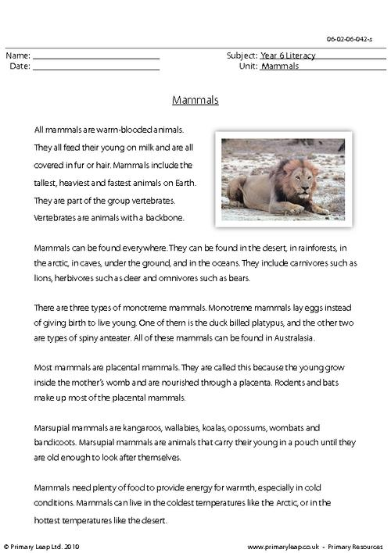

Macintosh HD:Users:melody:Desktop:Prepping for Grade 4 Classroom:Week Plans:E-Learning Materials:Week 2:Tuesday, April 14th:eat-read.pdf

