Name: ______________

Geometry Test

- Please name the shapes below and fill in how many faces, edges, and vertices they each have in the chart provided /28

Shape Picture | Name of Shape | Number of Faces | Number of Edges | Number of Vertices
a. 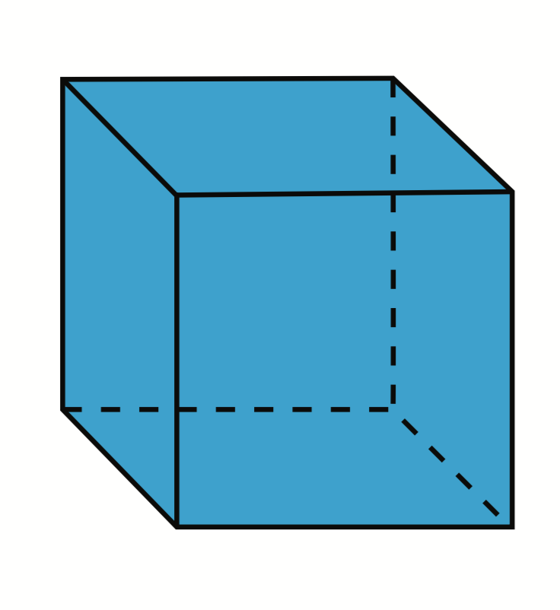
b. 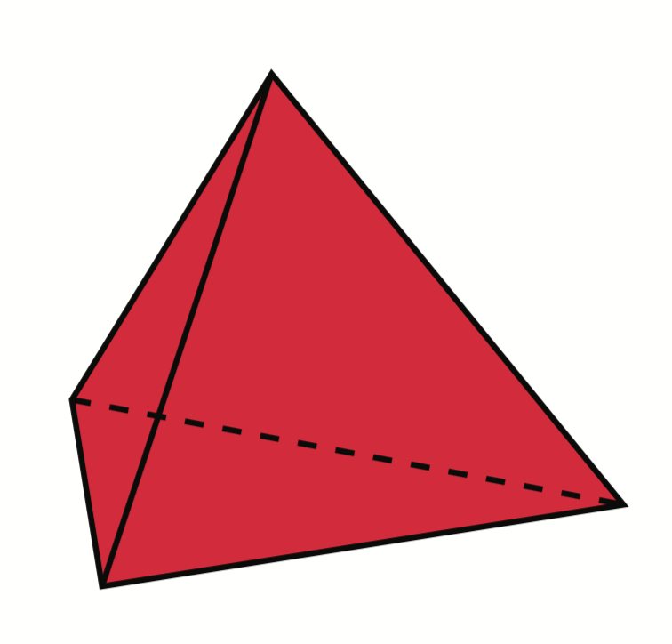
c. 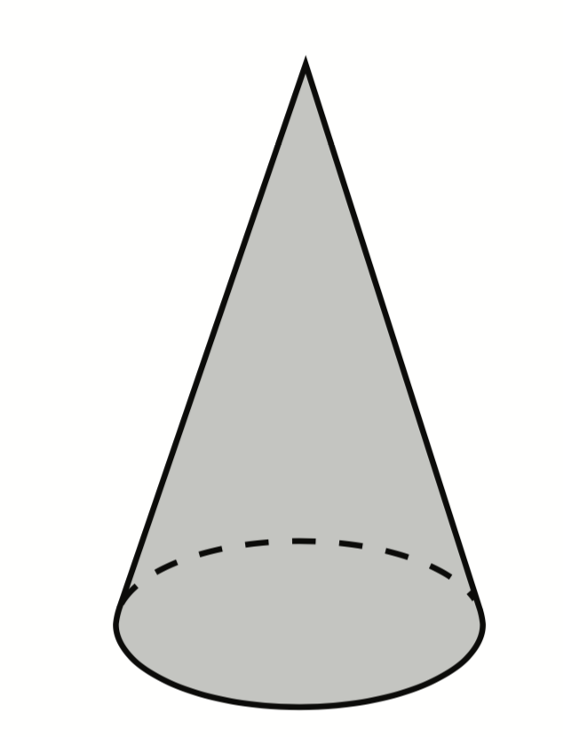
d. 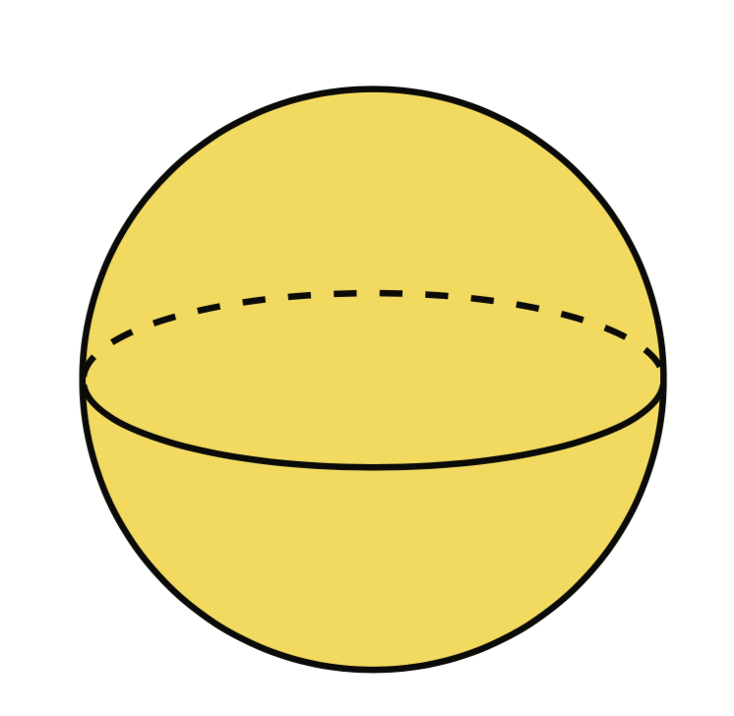
e. 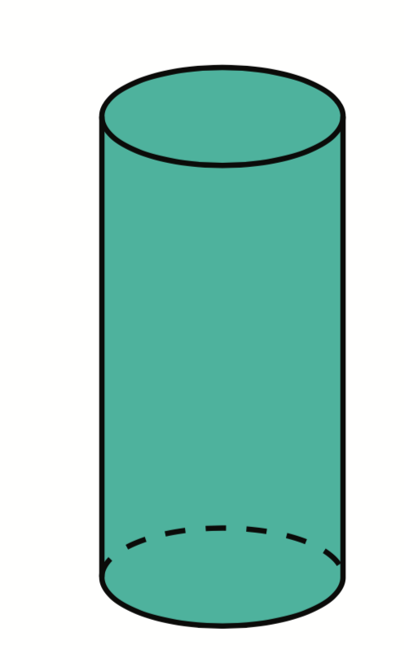
f.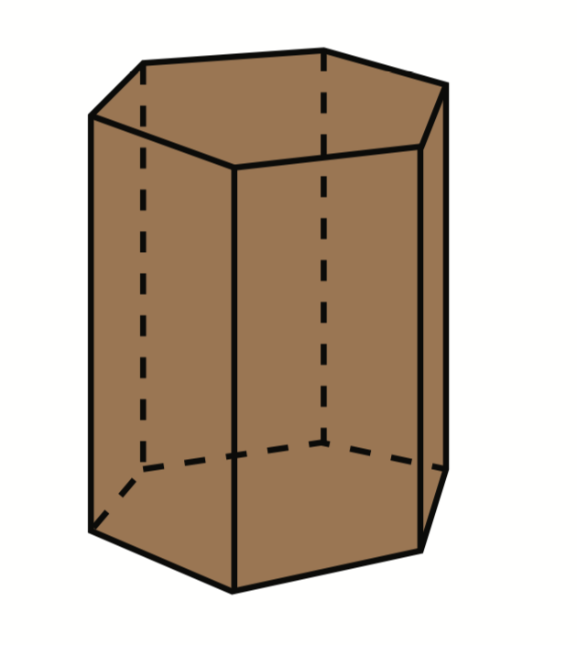
g. 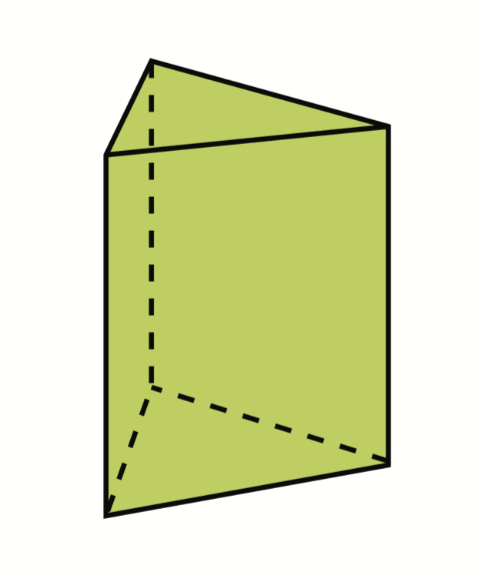

- Sort the following shapes into this Venn Diagram – write the letters in the Venn Diagram. /6

Has two or more congruent faces
Has at least one curved face

Both

a. b. c. d.

e. f.

- Name three examples for each shape (could be items in your house, objects outside, etc.) /6

Cube Cylinder
1. 1.
2. 2.
3. 3.

4. What does it mean if a shape is three-dimensional? /2

- Draw a net for the following shapes: /3

- cube

- triangular pyramid

c. cylinder

- How many lines of symmetry does each shape have? Draw them and write how many. /8

All sides
are equal

________ ____________ ___________ ____________

6. Finish the picture to show the mirror image over the dotted line. /4
a.) 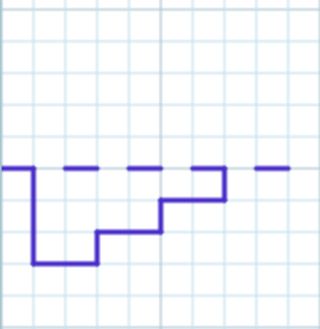 b.) 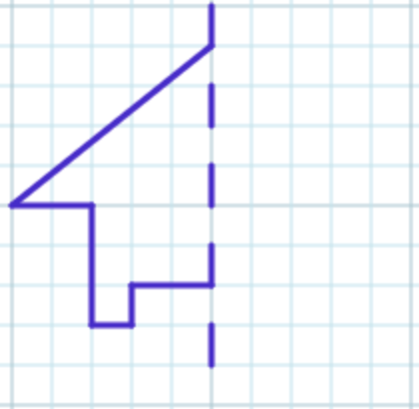
c.) 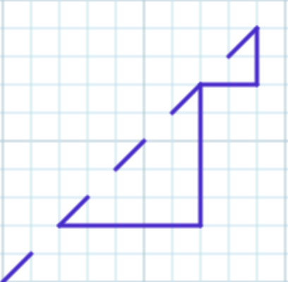 d.) 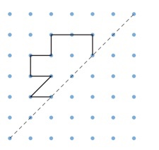 Mark out of 57 = /57

