BILL NYE THE SCIENCE GUY – PLANTS
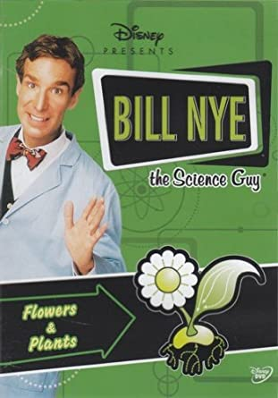
3-2-1 Watching Activity

What 3 things did you learn from the video?

1.________________________________________________________________

__________________________________________________________________

2.________________________________________________________________

__________________________________________________________________

3.________________________________________________________________

__________________________________________________________________

What 2 questions do you have after watching the video?

1.________________________________________________________________

__________________________________________________________________

2.________________________________________________________________

__________________________________________________________________

What 1 thing did you find the most interesting from the video?

1.________________________________________________________________

_________________________________________________________________

What was your favourite part of the video? And why?

Why?

______________________________________________________________________________

______________________________________________________________________________

______________________________________________________________________________

______________________________________________________________________________

______________________________________________________________________________

