Microsoft Bookings – Instructions for Families

This year, our school is using the Microsoft Bookings App to organize our family conferences. You do not need a Microsoft Account or the Teams App to participate in these virtual meetings. Follow these steps to set up your meetings with your child(ren)’s teacher(s).

Making an Appointment
Use the link provided by your child’s teacher to access the Bookings website for your school.
Set up your appointment by selecting the person you wish to meet with and the date/time you would like to book.

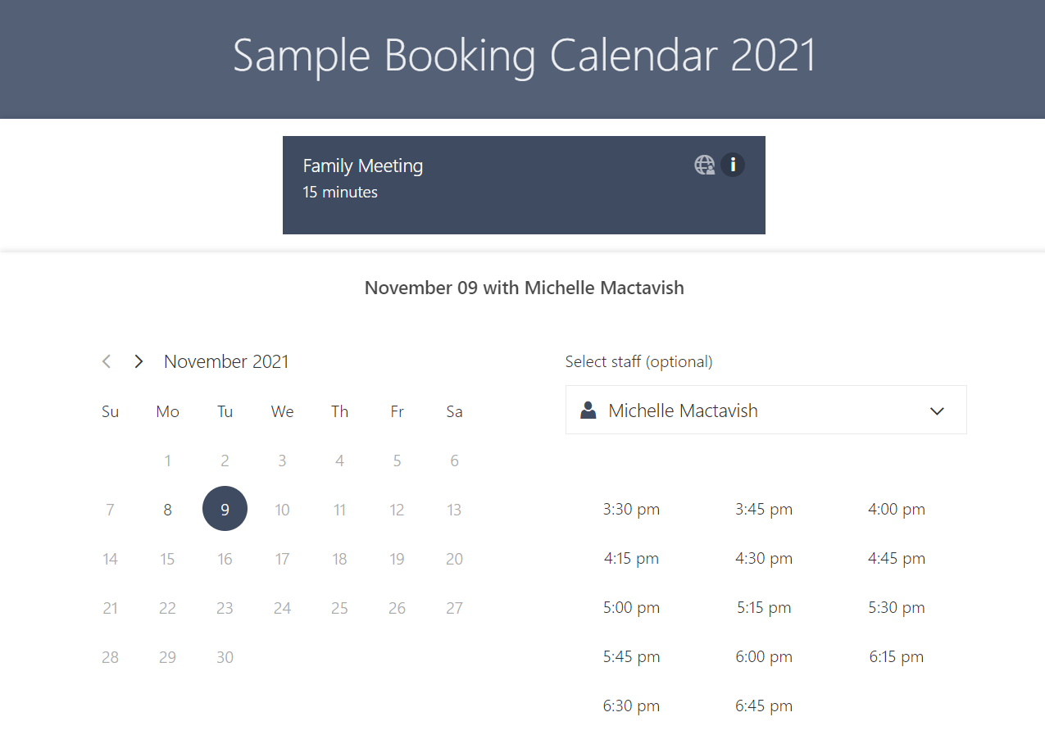

1) Use the Drop-down menu to select your child’s teacher.

3) Select a timeslot for your meeting

2) Use the calendar to select a date. Only dates shown in black can be booked *You may need to change the month using the arrows*

After you select the date and time for your appointment, scroll to the bottom of the page and fill in the registration form with your full name, your child’s name, and your email address.
You can also add additional notes if there is something specific you would like the teacher to know or address in your meeting. (See below for example of a registration form)

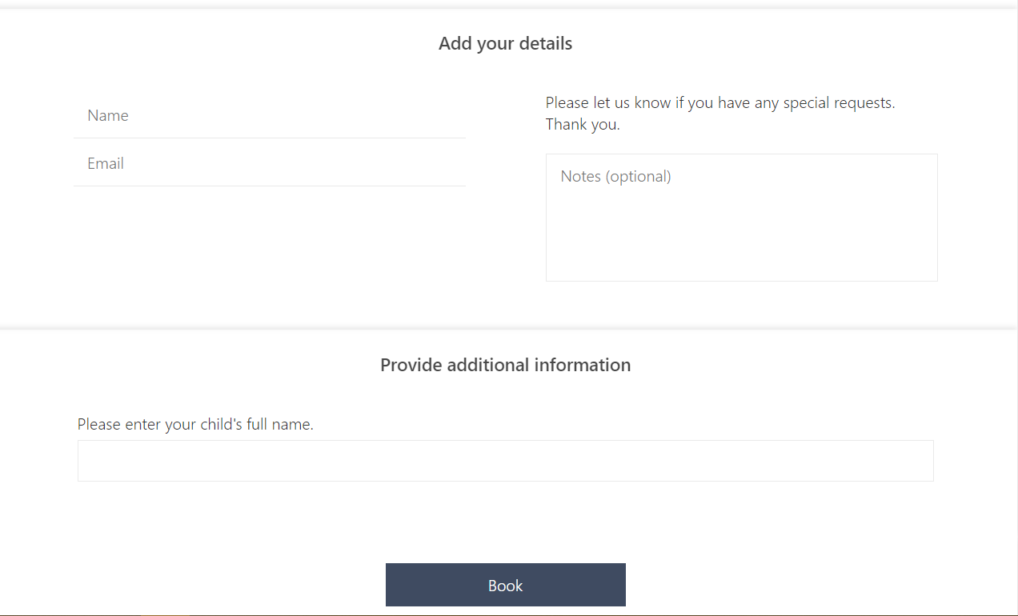

Click “Book” to complete your booking and then click “OK” on the confirmation box.
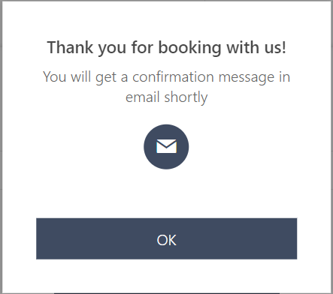
How to Book Meetings for Additional Children

After clicking “Ok” you can create an additional booking by clicking on “New Booking” on the confirmation page.

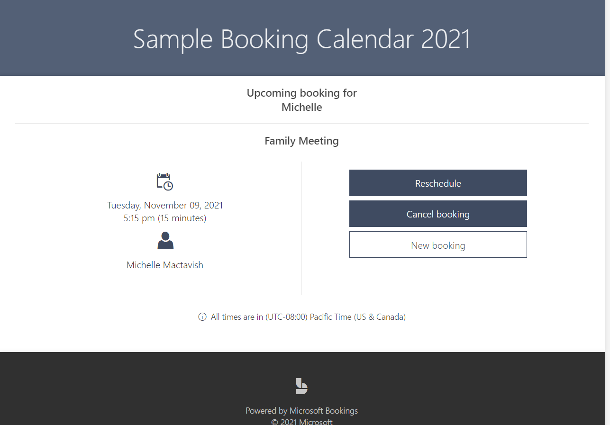

Repeat the steps above for each child at the school.
Take care not to book your appointments with more than one teacher for the same date/time slot.

Tip: Write down your first appointment date/time on a piece of paper before you book your next.

Your Email Conformation & Virtual Teams Meeting Link
After you make your booking you will receive an email confirmation message like the one below. You will need this email to join your virtual meeting. Click the “Join your appointment” button at the date/time of your appointment.

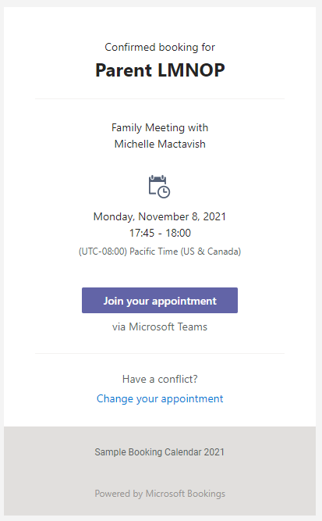

If you need to adjust your appointment, click the “Change your appointment” link to cancel and rebook.
How to Join Your Meeting
At the date and time of your scheduled meeting, click the “Join your appointment” button in your confirmation email.

Clicking this button will open your Microsoft Teams Meeting in a web browser.

Click “Allow” when you are asked to use your device’s microphone and camera.

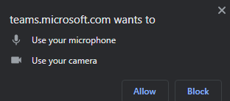

Next, enter your name and click “Join now” to enter your meeting.
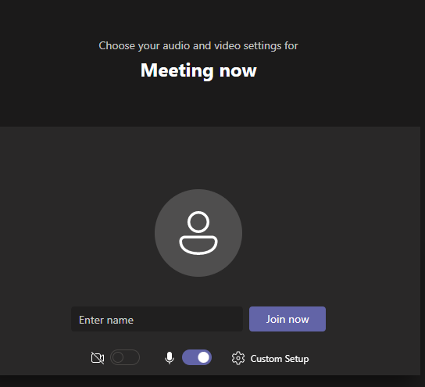

If you have questions about your appointment, please contact your child’s teacher.

