Father Day 2020

Father’s Day is this Sunday June 21.

Please create your own card using one of the following templates below for your Father or your Father figure in your life.

There are 4 options to choose from below.

Just like Mother’s Day choose an activity that your Dad enjoys or surprise him with something special. This can be completing an activity for him, giving him his favourite treat, making him breakfast. Include your other family members in on the surprise

Option 1: Collar Shirt Card (Can add a tie from below)

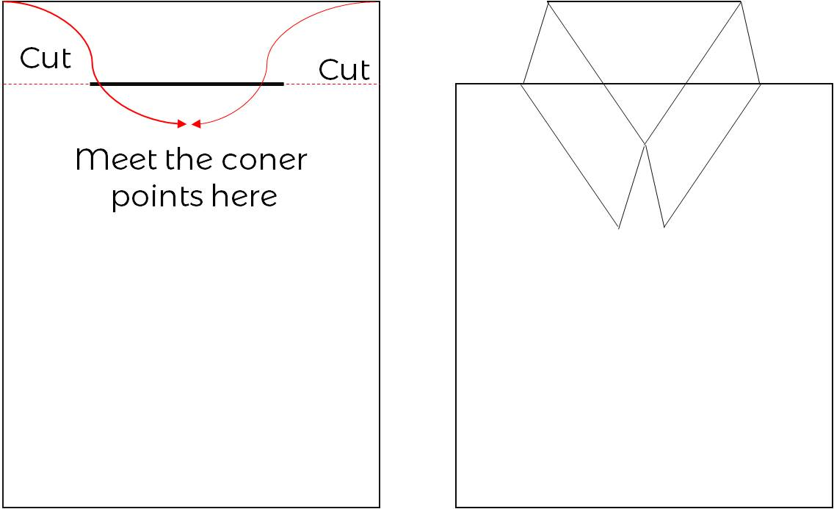

Option 2: Tie Card (it folds)
Option 3: Tie Book Mark
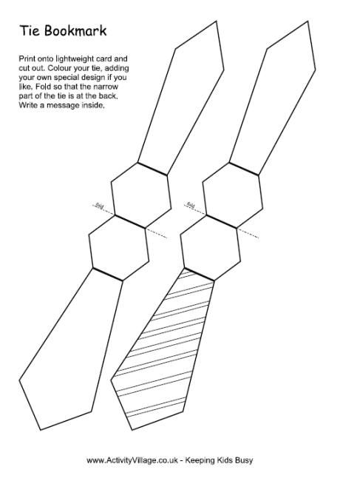

Option 4: Tie Fill In the Blank