READING BINGO
Read to your parents | Re-read your favourite book | Read a book that has a colour in the title | Read on the deck or patio | Read on a picnic blanket outside
Read a book about a sport | Read a book that takes place in a different city | Read a book that you love to read as a family | Read with or to a friend on zoom or facetime | Read a sequel (book number 2 in a series)
Listen to someone read to you | Listen to an audio book on Epic! or Raz-Kids | 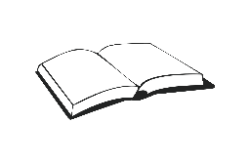  This Photo by Unknown Author is licensed under CC BY-SA | Read and cook a recipe from a cook book | Read in your favourite reading spot
Read a book with a family member that is out of your comfort zone | Read a book with an even amount a pages in it | Read a book chosen by your parents/ family member | Read in a tent or a fort | Read a book or part of a book that has a movie based on it with your parents
Read a book with expression | Read in your Pj’s | Read a book about an event in history | Read a book about science | Read to a pet or stuffed animal

