READING BINGO
Read to your parents | Record yourself reading on raz kids | Read outside | Listen to someone read to you | Read a book that makes you laugh
Read a book about animals | Read to a relative over the phone/ facetime | Read a book that you love | Read a book that is your parent’s choice | Read a book on epic or raz kids
Read a non-fiction book | Read under a table | 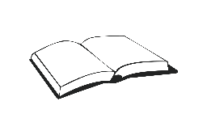  This Photo by Unknown Author is licensed under CC BY-SA | Re-read your favourite book | Read in your favourite reading spot
Read a book on your bed | Take turns reading with someone | Read while wearing a costume or a hat | Read in a tent or a fort | Read with a flashlight
Read with a stuffed toy/animal | Read in your Pj’s | Read a book about adventure | Read under a tree | Read in the living room

