The world population has now reached 7.5 billion people.
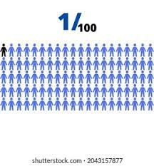
If the World Were 100 PEOPLE
(2016 data)

MY GUESS ACTUAL

Gender
_____ _____ would be female
_____ _____ would be male

AGE
_____ _____ would be 0 – 14 years old
_____ _____ would be 15 to 64 years old
_____ _____ would be 65 & older

GEOGRAPHY
There would be:
_____ _____ from Asia
_____ _____ from Africa
_____ _____ from Europe
_____ _____ from Latin America & Caribbean
_____ _____ from North America

RELIGION
_____ _____ Christians
_____ _____ Muslims
_____ _____ people would not be religious
_____ _____ Hindus
_____ _____ Buddhists
_____ _____ people who practice other religions

If the World Were 100 PEOPLE

MY GUESS ACTUAL
FIRST LANGUAGE
_____ _____ would speak Chinese
_____ _____ would speak Spanish
_____ _____ would speak English
_____ _____ would speak Hindi
_____ _____ would speak Arabic
_____ _____ would speak Bengali
_____ _____ would speak Portuguese
_____ _____ would speak Russian
_____ _____ would speak Japanese
_____ _____ would speak other languages
OVERALL LITERACY
_____ _____ would be able to read & write
_____ _____ wouldn’t be able to read & write
_____ _____ would have a college degree

TECHNOLOGY
_____ _____ would have a cell phone
_____ _____ would have an Internet connection
SANITATION
_____ _____ would have improved sanitation
_____ _____ would have no toilets

ELECTRICITY
_____ _____ would have electricity
_____ _____ would not

If the World Were 100 PEOPLE

MY GUESS ACTUAL
SHELTER
_____ ______ people would have a place to shelter themselves
from the wind and the rain, but ____would not
FOOD / INFECTIOUS DISEASE
_____ ______ would be undernourished
_____ ______ would have HIV/AIDS
_____ ______ would have tuberculosis (TB)
_____ _____ would be dying of starvation
_____ _____ would be overweight
DRINKING WATER
_____ _____ would have access to safe drinking water
_____ _____ people would have no clean, safe water to drink

POVERTY
_____ _____ would live on less than $1.90 USD per day

Sources: 2016 – www.100people.org

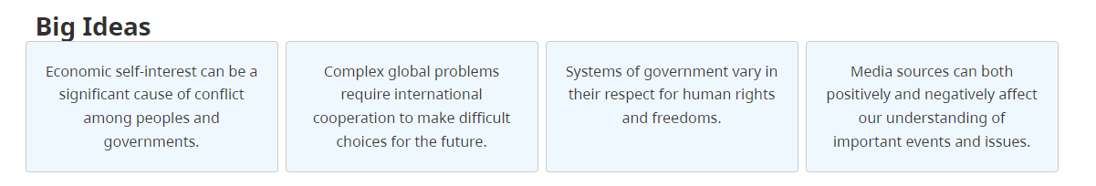
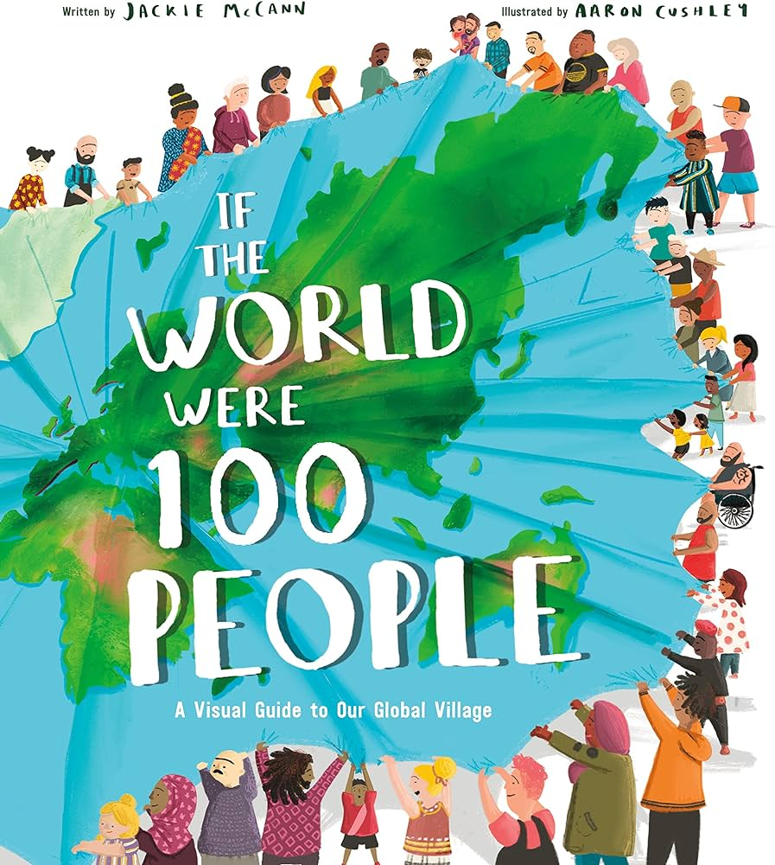
If the World Were 100 PEOPLE

Q 1 What data surprised you?

Q2 Do you recognize any problem(s) or issue(s)?

__________________________________________________________________________________________________________________________________________________________________________________________________________________________________________________________________________________________________________________________________________________________________________________________________________________________________________________________________________________________________________________________________________________________________________________________________________________________________________________________________________________________________________________________________________________________________________________________________________________________________________

