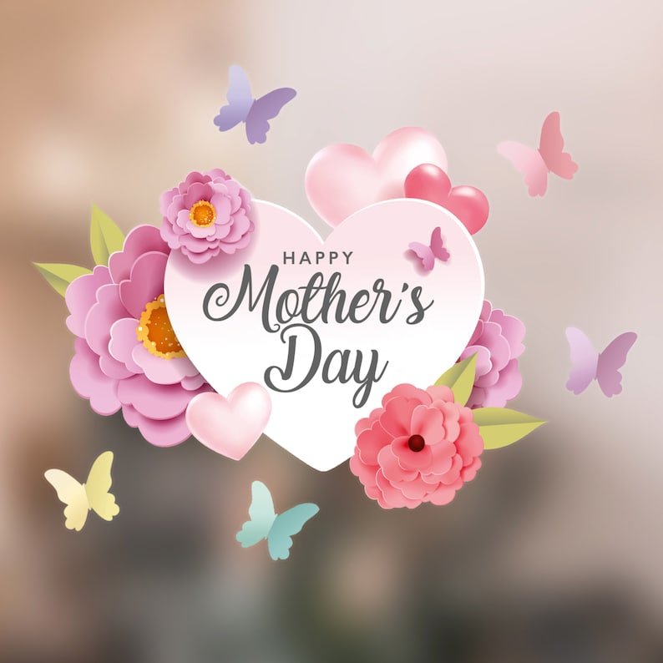
- Write a Mother’s Day poem based on the letters M-O-T-H-E-R
- You taught me the importance of… What one important thing or skill did your mother teach you? How has this thing helped you?
- I always think of you when… How has your mother helped you?
- I hope that in the future we… What would you like to do in the next few years or months with your mom?
- I always remember that time when…What is your favourite memory of your mom and you?

- My funniest memory of my mom is…
- When I think of my mom, I feel…
- If I were Mom-for-a-day, I would…
- The best advice my mom has ever given me is…
- The top 3, 5, 10 things I love about my mom are…

Youtube:
Google Mother’s Day gift ideas homemade crafts
DIY - SURPRISE MESSAGE CARD FOR MOTHER'S DAY | Pull Tab Origami Envelope Card | Mother's Day Card

