Let’s Learn About the Stock Market

What is the stock market and how does it work?

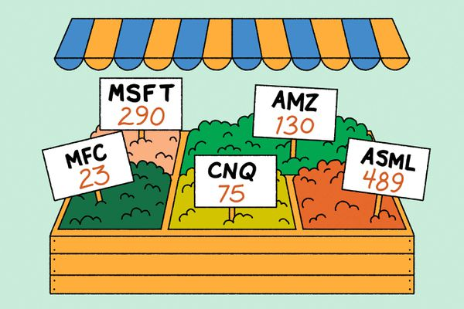

Investing in the [stock market](https://www.theglobeandmail.com/investing/markets/) is a good way to build wealth over time, but it can feel a little intimidating to get started. Understanding how the market works, the type of investments you can purchase through it, and your risk tolerance can help alleviate that stress.

What are stocks?

Holding stocks, also known as shares, means you have fractional ownership of a company traded on the stock market. It entitles you to benefit from the company’s earnings, through dividends and/or appreciation in the stock price.

Make a list of some stocks you may be interested in My name is: ____________

|  |  |  |  |  |  |  |  |  |  |
| --- | --- | --- | --- | --- | --- | --- | --- | --- | --- |
| **Name of Company** | **Ticker symbol** | **Which Stock Exchange** | **Which Industry** | **Price per share today**  **In USD** | Performance past 1m in $ /% | Performance past 6m in $/% | Performance  1Y in $/% | Performance  5Y in $/% | MAX $  Month  and year |
| e.g.  Transocean LTD. | RIG | NYSE | Offshore drilling contractors | $5.42 | +1.51  +38% | +2.67  +97% | +1.94  +55% | -6.78  -55% | $154.73  Apr  2008 |
|  |  |  |  |  |  |  |  |  |  |
|  |  |  |  |  |  |  |  |  |  |
|  |  |  |  |  |  |  |  |  |  |
|  |  |  |  |  |  |  |  |  |  |
|  |  |  |  |  |  |  |  |  |  |
|  |  |  |  |  |  |  |  |  |  |
|  |  |  |  |  |  |  |  |  |  |

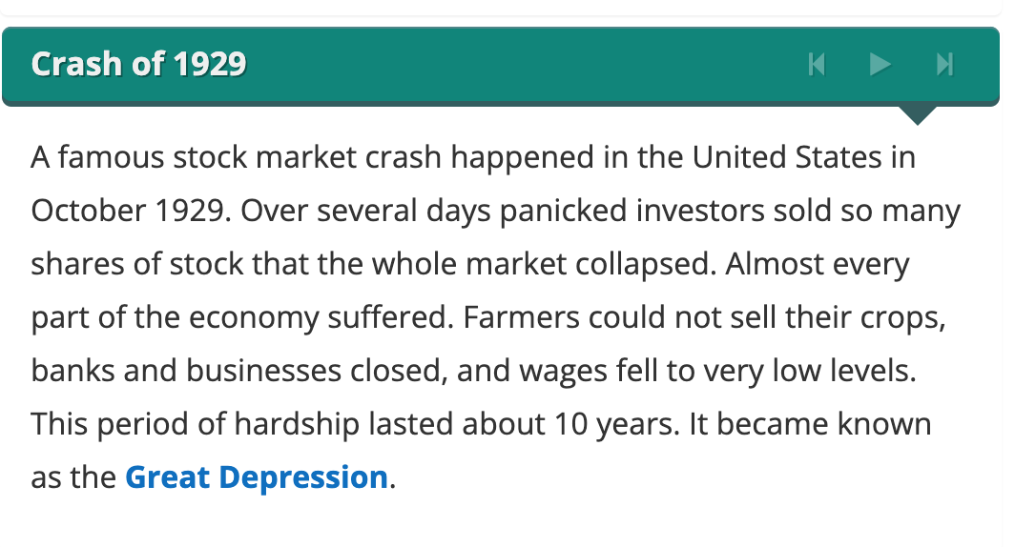**How much risk can you handle?**

Risk tolerance is the level of risk an investor is **WILLING** to take? Being able to accurately gauge your appetite for risk can be tricky. Risk can mean opportunity, excitement or a shot at big gains. But risk is also about losses, the ability to withstand market drops, and not being able to predict what is ahead.

1. When you hear "risk" related to your finances, how does it make you feel?

____________________________________________________________________________________________

1. Do you see an opportunity for great returns? ___________________________________________________
2. Do you imagine the "thrill" of investing? ________________________________________________________
3. Do you become worried that you’ll be left with nothing? ___________________________________________
4. Do you believe that risk is just an essential part of the investing process? ______________________________
5. Where do you fall on the risk tolerance line?

0 5 10



**LOW** risk tolerance **HIGH** risk tolerance

Make a list of stocks you will buy for USD$_______ My name is: ____________#

Today is: _______________ End Date Will BE ON: ______________________

|  |  |  |  |  |  |  |  |  |  |
| --- | --- | --- | --- | --- | --- | --- | --- | --- | --- |
| **Name of Company** | **Ticker symbol** | **Which Stock Exchange** | **Which Industry** | **Price per share today**  **In USD** | **How many shares will you buy?** | **TOTAL**  Price per share times # of shares | **Price per share one week later** | Total one week later | Did you make a profit or a loss? |
| e.g.  Transocean LTD. | RIG | NYSE | Offshore drilling contractors | $5.42 | 20 | $108.40 | $6.20 | $124 | + $15.60 |
|  |  |  |  |  |  |  |  |  |  |
|  |  |  |  |  |  |  |  |  |  |
|  |  |  |  |  |  |  |  |  |  |
|  |  |  |  |  |  |  |  |  |  |
|  |  |  |  |  |  |  |  |  |  |
|  |  |  |  |  |  |  |  |  |  |
|  |  |  |  |  |  |  |  |  |  |