Grade 6 Social Studies
International cooperation and responses to global issues

My Pandemic Project
Which pandemic will you become an expert in?
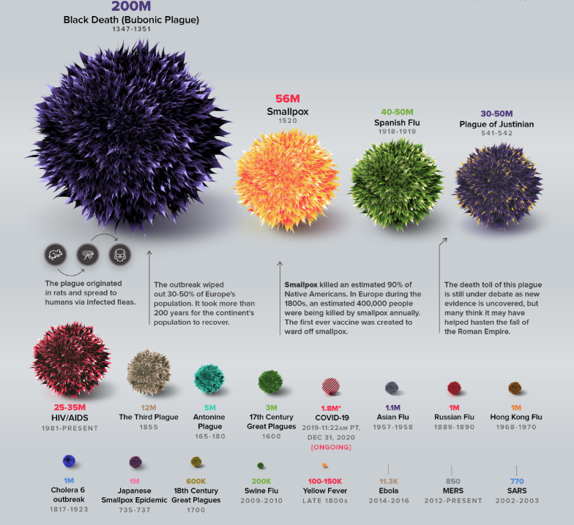
https://www.visualcapitalist.com/history-of-pandemics-deadliest/
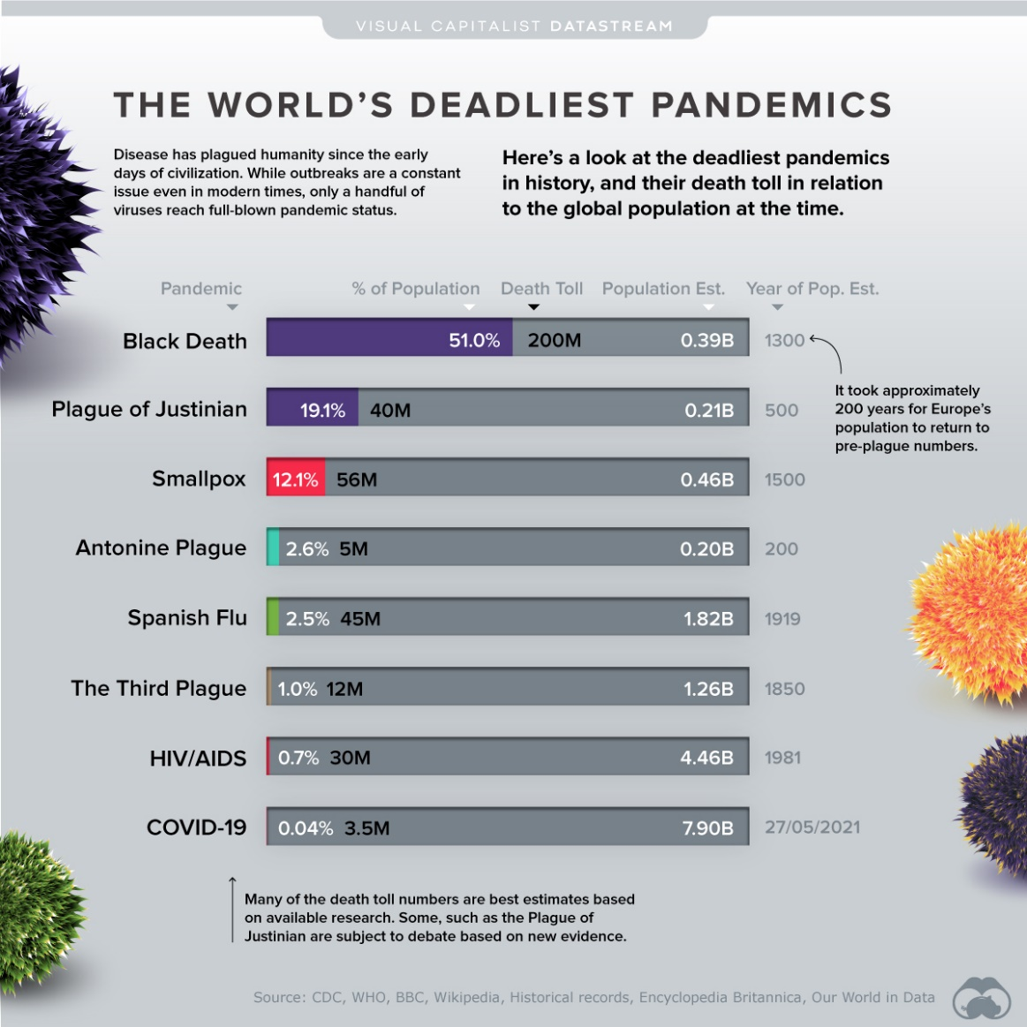
TO DO
Imagine that you have been asked to deliver a paper on behalf of the World Health Organization on the effects of a pandemic. There have been many different pandemics that have occurred throughout history. Select one of these and research as much as you can about your selected pandemic.
Below are some questions to help you research and develop your paper (assignment):

My Note-Taking
Define what an epidemic is | Define what a pandemic is
What organization officially declares pandemic status?

NAME OF THE PANDEMIC YOU CHOSE:

When did this pandemic occur? | Where did this pandemic first occur?
What caused the pandemic?

Did this pandemic affect regions of the world differently?

What were the symptoms? | Were any particular persons most or more affected?
How was it transmitted? | How was it contained?
Which parts of the world were most affected? | How many people died?
How did it affect local and global communities?

What solutions would you put in place to prevent:
(a) another occurrence of this pandemic?
(b) it from spreading?

Deliver your paper to your teacher and classmates as if they were at the World Health Organization (WHO) conference. Maximum 2 pages! Use only one side of the paper.

