My name is: _____________________ #: ____

DUE ON: …………………………………………………..

ATTENTIVENESS | I stay on task during class and avoid distractions | rarely | sometimes | usually | always

CONTRIBUTION | I contribute to discussions and other activities | rarely | sometimes | usually | always

EFFORT | I go over my work and use feedback to improve | rarely | sometimes | usually | always

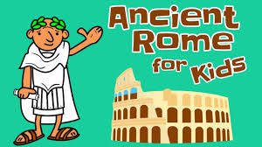

Lesson 5 of 5
The End of an Empire

Use textbook Ancient Worlds, Oxford, 2000

What was your greatest challenge in this booklet?

Which section did you enjoy the most?

LEVEL OF ACHIEVEMENT
READING  SOCIAL STUDIES | incomplete | beginning | developing | proficient | extending

TODAY IS: _____________________________

The End of an Empire

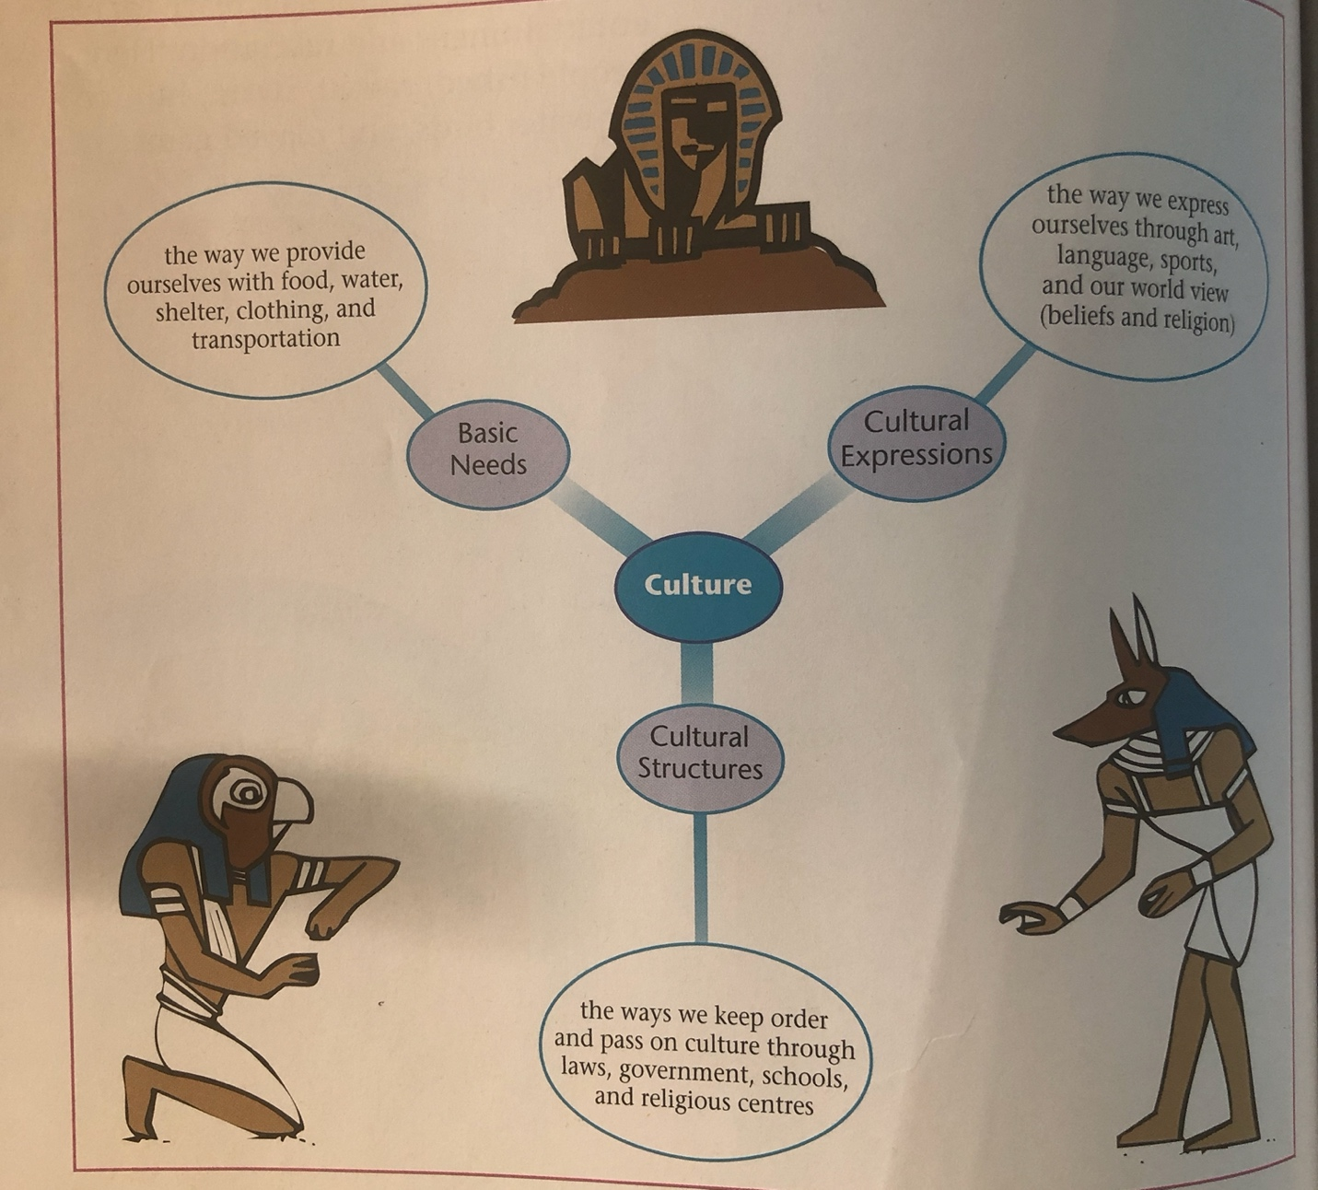
Q1. Go to page 90 to look at a culture web. Discuss it. Did you notice the three categories? You are going to give a quick rating of the success of the Roman Empire based on what you have studied so far in readings and videos.

Culture

Q (1) To Do: Notice the words below in bold.
You will give a quick rating of 4, 3, 2 or 1.
Write the bolded word under the number you think it belongs to.

Basic Needs | Cultural Structures | Cultural Expressions
The way they provided themselves with food | The way they kept order | The way they expressed themselves through art
The way they provided themselves with water | The way they passed on culture through laws | The way they expressed themselves through language
The way they provided themselves with shelter | The way they passed on culture through government | The way they expressed themselves through sports
The way they provided themselves with clothing | The way they passed on culture through schools | The way they expressed themselves through religious beliefs
The way they provided themselves with transportation | The way they passed on culture through religious centres

The Roman Empire developed a culture that was:

extremely successful | somewhat successful | somewhat unsuccessful | unsuccessful
4 | 3 | 2 | 1

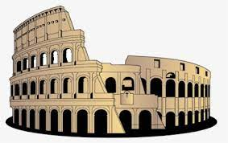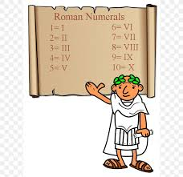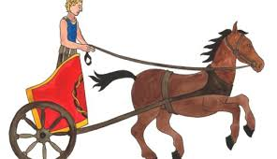
Q2. See page 192
The End of an Empire

For several ________________ , Rome brought peace, law, and order to most of the provinces of the empire. Then gradually, the empire began to ______________ . As Rome grew weaker within, invading ______________ from beyond the ____________ frontiers ___________ . Finally, even the city of ____________ fell to _________________ .

The Romans thought their world would last ______________ . Why did it fall?

Q3. Copy the small yellow box on page 193 (top right).

_______________________________________________________________
_______________________________________________________________
_______________________________________________________________
_______________________________________________________________
_______________________________________________________________

Q4. Your teacher will form small discussion groups to share what you have written.
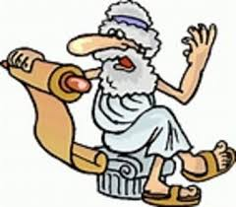
Members of my group are: ………………………………………………………….

Pick a couple of your ratings. Why did you give it that rating?

I rated (bolded words goes here)____________________________
4 3 2 1 because ______________________________________
_____________________________________________________
_____________________________________________________

I rated (bolded words goes here)____________________________
4 3 2 1 because ______________________________________
_____________________________________________________
_____________________________________________________

Activity: Decline of the Roman Civilization

Q5. Read aloud as a class pages 192 – 193, discussing each factor that may have contributed
to the decline of the Roman Empire. Make sure to complete all 8 bullets.

- In the left column, copy the bullet with the words in bold. The first one has been done for you.
- Now jot down the effect. Cause and effect refers to a relationship between two phenomena in which one phenomenon is the reason behind the other. For example, eating too much fast food without any physical activity causes the effect of your gaining weight.

Cause | Effect
• It abandoned the Greek ideal of democracy
•

•

•

•

•

•

•

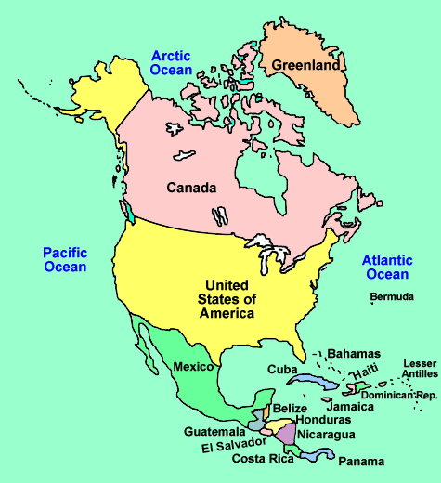
Homework
Where are we now?

Think back! You may need to do a bit of research.

Q6. Did Canada ever try to increase its borders by taking over the land of others?

Q7. Did Canada try to control other people? If so, what means or methods were used?

Q8. Do we face some of the same problems of running an empire that Rome did?

Use the space below as well as the next page to record your responses.

