Chapter 1
READING FOR INFORMATION
Extending (4) Proficient (3) Developing (2) Emerging (1) Incomplete Late Not Done
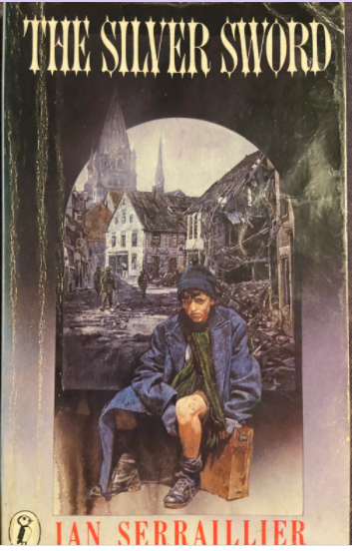
- When and where is this story set?
_____________________________________________
- What major historical event is the setting for this story? ______________________________

- Name the 5 members of the Baliki family (include ages if you can)

- What was Joseph Balicki’s profession? _________________________________________

- When the Nazis took Joseph away to prison, how old was Bronia? _____________

- Upon which member of the family did great responsibilities fall? ___________________

- What was the name of the prison camp? __________________________________

- For how many months of the year at the prison camp did the snow lie “thick upon the ground”?
____________________________

- True or false? Most of the prisoners in the camp were Hungarians. ________________
- At his old school, whose picture had Joseph turned to the wall? ________________________
- What was inside the double fence, to stop prisoners escaping? __________________________
- What did Joseph do to get into ‘the cooler’?
_____________________________________________________________________________
- Where did the stone (that Joseph used with his catapult) strike the guard?
______________________________________________________________
- In which block were the Hungarian and Romanian prisoners kept? ________________________

Chapter 1
READING FOR COMPREHENSION
Extending (4) Proficient (3) Developing (2) Emerging (1) Incomplete Late Not Done

- Draw a quick sketch of what life was like in the Zakyna prison camp.

- Joseph is doing very poorly during his time at the prison camp. What keeps him alive?

- Why did Joseph NOT try to escape the first winter he was at the prison camp?

- Why would solitary confinement be used as a punishment in prison?

- What did Joseph have to be careful of in the cooler?

- What do you think was the most dangerous part of Joseph’s escape? Why?

- How would Joseph have felt as he walked away from the prison?

- How does the author create suspense at the end of chapter 1?

