Activity
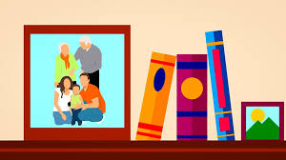
Learning From Generation to Generation

Key Concepts
- Respect for the land is at the centre of First Nations culture and education.
- In traditional First Nations culture, education was a family matter.

Key Questions
In what ways can people show respect for the land?

What do we learn from our families?

How do people pass on cultural knowledge from generation to generation?

HOW AND WHAT DO WE LEARN AT HOME?
Is everything you know learned at school?

What kinds of things do we learn at home? | Who are your teachers at home?
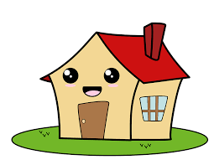
HOW AND WHAT DO I LEARN AT MY OWN HOME?
Student is to work together with a parent(s) to list different things they learn at home with their families. Classify the things you learn into groups (e.g. behaviours, skills, beliefs).
BEHAVIOURS | SKILLS | BELIEFS/MORALS

What language(s) do you speak at home? ______________________________________________________________________________
Why is it important to use languages other than English?
________________________________________________________________________________
________________________________________________________________________________
________________________________________________________________________________

