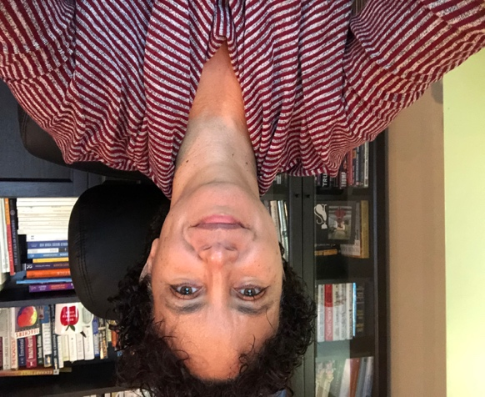
Dear wonderful student,
from the home desk of Mrs. Smith

Welcome back from March Break!

These are strange and unusual times indeed. These past few weeks have been truly unlike anything we’ve experienced before.

I managed to get married on 3.20.2020, just in time before things started closing down. It was an epic heli-wedding. Here are some snapshots (Golden Ears peaks).
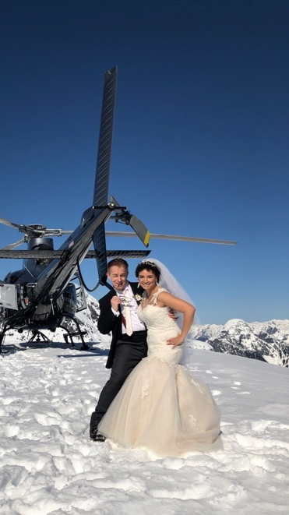

Our classrooms may be dark and empty for now, but I’m excited to welcome you to remote learning. You may have heard that BC schools are closed indefinitely. During this school closure, due to the Covid-19 pandemic, we want to provide students with a sense of connection, normalcy, and routine to help keep you engaged in your own learning. This letter will help get you information about what teaching and learning will look like in the weeks to come.

No doubt, some of you have been following my Remind texts and have delved back into your schoolwork with dedication and energy. I see that 14 students have already begun IXL Reading and English. It’s a free 30 days trial--so make good use of it before time runs out. I have also signed up the class for epic books (free until end of June). I can track you on IXL and epic books.

Students are expected to check our class website every weekday (M-F) to see what Homework is due. During these extraordinary times, you are unlikely to spend the same hours on schoolwork as you would if you were actually at school. That’s ok. It is okay to pace yourself and make sure that taking care of yourself and your family members is a priority. Remember to get some physical exercise.

I will continue to communicate with your parents via Remind text. I will communicate with students using our class website Homework Due page. I will also contact you via Office365. We can still connect and help one another.

Students should keep in touch with me using their Office365 Outlook e-mail pupil#@edu.burnabyschools.ca
Or text me on Remind.

Please know that I miss your wonderful presence at school and am thinking of you.

Stay healthy and try not to drive your parents crazy!

Sincerely,

Mrs. Smith
joanne.smith@burnabyschools.ca

