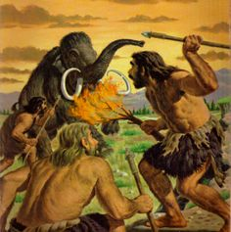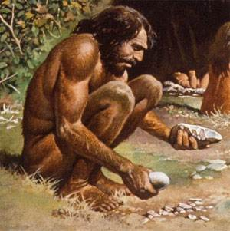
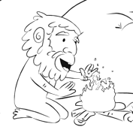
Clearly, fire played a very important role in the evolution of our species. Humans are the only animals that know how to control and create fire. Fire is one key way in which mankind is separate from all other species.

DRAFT IN PENCIL
cover | Your full name and student number at the bottom  The title is: create your own title
Page 1 | How Did Early Humans Discover Fire?
Page 2 | Describe a way they used fire and include an illustration (drawn or clipart)
Page 3 | Describe a way they used fire and include an illustration
Page 4 | Describe a way they used fire and include an illustration
Page 5 | Describe a way they used fire and include an illustration
Page 6 | Describe a way they used fire and include an illustration
Back cover | What is the BIG IDEA?  This last page is very important and will be worth a lot of marks!

You may use:
- The textbook
- Overhead notes you copied down / Videos shown in class
- Encyclopedia
- Any of the library books Ms. Smith has in the classroom
- Talking about it with other people

GRADING: Extending Proficient Developing Emerging Incomplete

Assigned on: ____________________________ Due On: ……………………………………………………………….

