Science & Technology Homework

The t _ _ _ _ _ _ _ _ y I will research is:

- telescope
- microscope
- X-ray machine
- rocket ship
- submarine
- computer

- a) Did someone get credit for inventing it?

b) When?

- Briefly describe how it works.

- What problem did it solve?

- How does it make life easier/help us?

- Does it have a destructive use? Bad?

- Can it harm our environment (air, water, land, climate)?

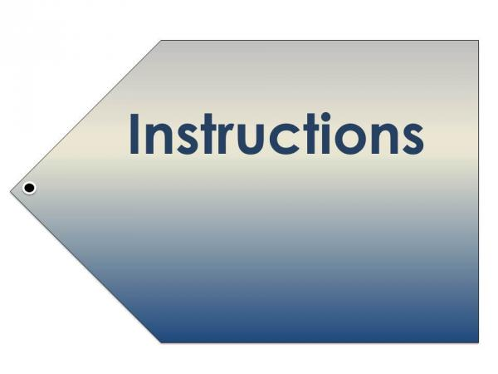
HOW TO DO IT
- Create a short report (2 pages max.).
- Add at least one diagram/clip art.
- You may write it with a pencil or pen.
- You may use Adobe Spark Video (free app) for iPhone/iPad/Ipod
    - E-mail is: division2smith@gmail.com
    - password is: ask me
- You may use your Office365 school account pupilnumber@edu.burnabyschools.ca

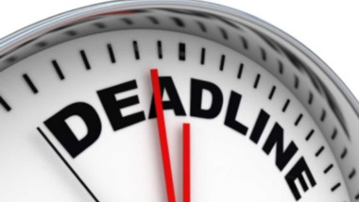
DATES
Assigned on: ………………………………………………….. Tue Oct 22
Due: …………………………………………………………….. Monday Oct 28, 2019
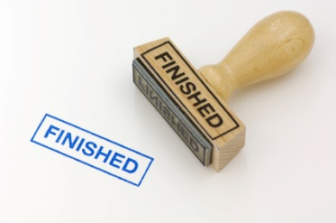
I used __________________________________________ to complete my assignment.
*****(Office365, Adobe Spark Video, Other___________-explain)

- I would like you to notice

- I feel _________________________________________ about my learning because

