2 Chord Songs: D, A7

BABY SHARK

D

Baby shark, doo doo doo doo doo doo.

D

Baby shark, doo doo doo doo doo doo.

D

Baby shark, doo doo doo doo doo doo.

A7

Baby shark

Mommy shark

Daddy shark

Grandma shark

Grandpa shark

Let’s go hunt

Run away

Safe at last

It’s the end

THE HOKEY POKEY

 | D | D
You put your | right foot in, You put your | right foot out;

 | D | A7
You put your | right foot in, And you | shake it all about.

 | A7 | A7
You | do the Hokey Pokey, And you | turn yourself around.

 | A7 | D
 | That's what it's all a- | bout!

You put your left foot in . . .

You put your right hand in . . .

You put your left hand in. . .

You put your head in . . .

You put your whole self in . . .

Head, Shoulders, Knees and Toes
D A7 D
Head and shoulders, knees and toes, knees and toes, knees and toes,
D
Head and shoulders, knees and toes,
A7 D
Eyes, ears, mouth, and nose

FOUND A PEANUT

D A7

Found a peanut, found a peanut, found a peanut last night.

D A7 D

Last night I found a peanut, found a peanut last night.

D A7

Cracked it open, cracked it open, cracked it open last night.

D A7 D

Last night I cracked it open, cracked it open last night.

D A7

Found it rotten, found it rotten, found it rotten last night.

D A7 D

Last night I found it rotten, found it rotten last night.

D A7

Ate it anyway, ate it anyway, ate it anyway last night.

D A7 D

Last night I ate it anyway, ate it anyway last night.

D A7

Got a stomach ache, got a stomach ache, got a stomach ache last night,

D A7 D

Last night I got a stomach ache, got a stomach ache last night.

D A7

Called the doctor, called the doctor, called the doctor last night.

D A7 D

Last night I called the doctor, called the doctor last night.

D A7

Cut me open, cut me open, cut me open last night.

D A7 D

Last night he cut me open, cut me open last night.

D A7

Died anyway, died anyway, died anyway last night,

D A7 D

Last night I died anyway, died anyway last night.

D A7

Went to heaven, went to heaven, went to heaven last night.

D A7 D

Last night I went to heaven, went to heaven last night.

D A7

Wouldn’t take me, wouldn’t take me, wouldn’t take me last night.

D A7 D

Last night they wouldn’t take me, wouldn’t take me last night.

D A7

Went the other way, went the other way, went the other way last night.

D A7 D

Last night I went the other way, went the other way last night.

D A7

Burned to ashes, burned to ashes, burned to ashes last night.

D A7 D

Last night I burned to ashes, burned to ashes last night.

MICHAEL FINNIGAN
D
There was an old man named Michael Finnigan
A7
He grew whiskers on his chinnigan
D
The wind came up and blew them in again
A7 D
Poor old Michael Finnigan, begin again
D
There was an old man named Michael Finnigan
A7
He fell down and broke his shinngain
D
Folks said, “Mike, you’ll never swim again”
A7 D
Poor old Michael Finnigan, begin again
D
There was an old man named Michael Finnigan
A7
He grew fat and then grew thin again
D
Thinner than a safety pinnigan
A7 D
Poor old Michael Finnigan, begin again

The Wheels on the Bus
D
The wheels on the bus go round and round
A7
Round and round, round and round
D
The wheels on the bus go round and round
A7 D
All through the town
The people on the bus go up and down……
The wipers on the bus go swish, swish, swish….
The horn on the bus goes beep, beep, beep…..
The children on the bus make too much noise…..
The driver on the bus says "tickets please”…..
3 Chords: D,G,A7

Old McDonald Had a Farm

D G D A7 D
Old MacDonald had a farm, E-I-E-I- O!
D G D A7 D
And on his farm he had a chick, E-I-E-I- O!
D D
With a cluck-cluck here, and a cluck-cluck there
D D
Here a cluck, there a cluck, everywhere a cluck-cluck
D G D A7 D
Old MacDonald had a farm, E-I-E-I- O!

Chick…cluck
Cow…moo
Duck....quack
Pig…oink
Horse…neigh
Sheep…baa

This Old Man

D
This old man, he played one,
G A7
He played knick knack on my thumb,
D
With a Knick, knack, paddy whack,
D
Give the dog a bone;
A7 D
This old man came rolling home.

Two…with my shoe
Three…on my knee
Four…on my door
Five…on my hive
Six…with my sticks
Seven…up in heaven
Eight…on my gate
Nine…on my spine
Ten…in my den

If You’re Happy And You Know It
D A7
If you’re happy and you know it clap your hands (clap clap)
A7 D
If you’re happy and you know it clap your hands (clap clap)
G D
If you’re happy and you know it and you really want to show it
A7 D
If you’re happy and you know it clap your hands (clap clap)

(Replace “clap your hands” with: “stomp your feet” or “shout hurray”)
D A7
If you’re happy and you know it do all three (clap clap, stomp stomp, “hurray!”)
D A7
If you’re happy and you know it do all three (clap clap, stomp stomp, “hurray!”)
G D
If you’re happy and you know it and you really want to show it
A7 D
If you’re happy and you know it do all three (clap clap, stomp stomp, “hurray!”)

On Top of Spaghetti

D G D
On top of spaghetti all covered with cheese
A7 D
I lost my poor meatball when somebody sneezed.
G D
It rolled off the table and onto the floor
A7 D
And then my poor meatball rolled out of the door.

D G D
It rolled in the garden and under a bush
A7 D
And then my poor meatball was nothing but mush.
G D
The mush was as tasty, as tasty could be,
A7 D
And early last summer, it grew into a tree.

D G D
The tree was all covered with beautiful moss.
A7 D
It grew great big meatballs and tomato sauce.
G D
So if you eat spaghetti all covered with cheese,
A7 D
Hold on to your meatballs and don’t ever sneeze.

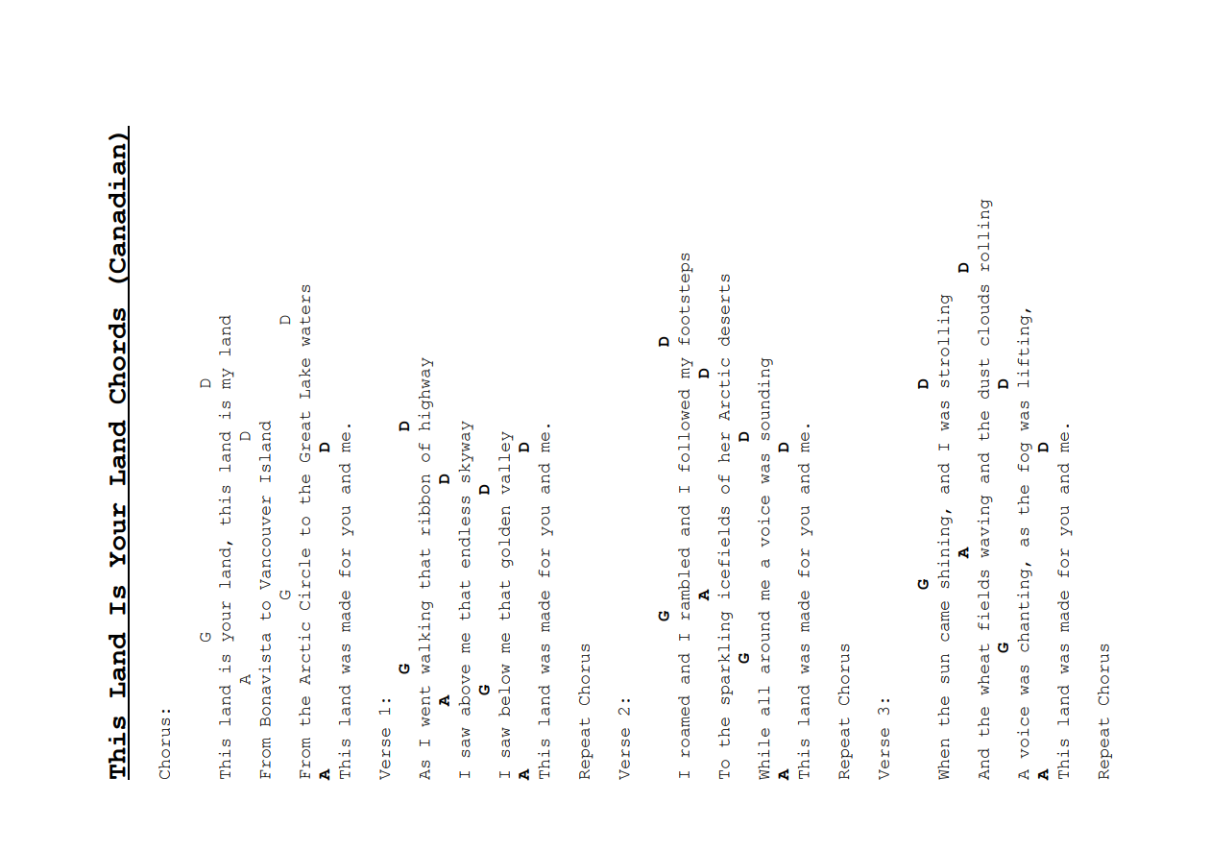

The Quartermaster’s Store

D
There were rats, rats, big as alley cats
A7 D
In the store, in the store
D
There were rats, rats, big as alley cats
A7 D
In the Quartermaster’s store

Chorus:
D G
My eyes are dim, I cannot see
A7
I have not got my specs with me
D G A7 D
I have not got my specs with me

D
There were flies, flies eating apple pies
A7 D
In the store, in the store
D
There were flies, flies, eating apple pies
A7 D
In the Quartermaster’s store

(Chorus)

D
There was gravy, gravy, enough to float the Navy
A7 D
In the store, in the store
D
There was gravy, gravy, enough to float the Navy
A7 D
In the Quartermaster’s store

(Chorus)

D
There was dust, dust, hardened to a crust
A7 D
In the store, in the store
D
There was dust, dust, hardened to a crust
A7 D
In the Quartermaster’s store

(Chorus)

D
There was food, food, my but it was good
A7 D
In the store, in the store
D
There was food, food, my but it was good
A7 D
In the Quartermaster’s store

(Chorus)

D
There were snakes, snakes, big as garden rakes
A7 D
In the store, in the store
D
There were snakes, snakes, big as garden rakes
A D
In the Quartermaster’s store

(Chorus)

The Lion Sleeps Tonight

D
A whimoway, a whimoway,
G
A whimoway, a whimoway,
D
A whimoway, a whimoway,
A7
A whimoway, a whimoway,
(repeat)

D G
In the jungle the mighty jungle,
D A7
The lion sleeps tonight.
D G
In the jungle the mighty jungle,
D A7
The lion sleeps tonight.
D G D A7
Wee-ee-ee-oh-wee-o whimoway (repeat)

D G
In the village, the quiet village,
D A7
The lion sleeps tonight.
D G
In the village, the quiet village,
D A7
The lion sleeps tonight.
D G D A7
Wee-ee-ee-oh-wee-o whimoway

D
A whimoway, a whimoway,
G
A whimoway, a whimoway,
D
A whimoway, a whimoway,
A7
A whimoway, a whimoway,

She’ll Be Coming ‘Round the Mountain

D
She’ll be coming ‘round the mountain when she comes. (Toot, toot)
A7
She’ll be coming ‘round the mountain when she comes. (Toot, toot)
D
She’ll be coming ‘round the mountain,
G
She’ll be coming ‘round the mountain,
D A7 D
She’ll be coming ‘round the mountain when she comes. (Toot, toot)

D
She’ll be driving six white horses when she comes. (Whoa back!)
A7
She’ll be driving six white horses when she comes. (Whoa back!)
D
She’ll be driving six white horses,
G
She’ll be driving six white horses,
D A7 D
She’ll be driving six white horses when she comes. (Whoa back!)

D
Oh we’ll all go out and meet her when she comes. (Hi, babe!)
A7
Oh we’ll all go out and meet her when she comes. (Hi, babe!)
D
Oh we’ll all go out and meet her,
G
Oh we’ll all go out and meet her,
D A7 D
Oh we’ll all go out and meet her when she comes. (Hi, babe!)

D
She’ll be coming ‘round the mountain when she comes. (Toot, toot)
A7
She’ll be coming ‘round the mountain when she comes. (Toot, toot)
D
She’ll be coming ‘round the mountain,
G
She’ll be coming ‘round the mountain,
D A7 D
She’ll be coming ‘round the mountain when she comes. (Toot, toot)

