Monday | Tuesday | Wednesday | Thursday | Friday
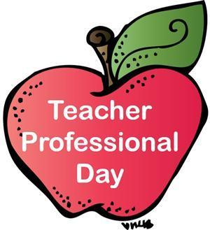 | Raz Kids  Listen, Read, questions  new story | Raz Kids  Record, write Reflection  of same story | Proof Reading  See Assignments | Tumble Books  Library
 | Spelling  See FILES in team under your grade. | Writing  In Teams Class Notebook go to the journal tab to make your written response to today’s reading. | Spelling  See FILES in team under your grade | Spelling  Grade meetings to mark work and have spelling test
 | Math  See Assignments | Math  Code.Org | Math  See Assignments | Math  See Assignments
 | Music  Mrs. Viekles Blog | Socials  See assignments in Teams | Typing  Typing.com | Field Trip Fridays  Beluga Play Time
 | PE  Happy Dance | Choices  Choose any game or toy or invent your own | PE  Mini The Puppy Cosmic Yoga | Art  How to Draw a Beluga Whale
Week: June 9th – 12th Opportunities For Learning

