Monday | Tuesday | Wednesday | Thursday | Friday
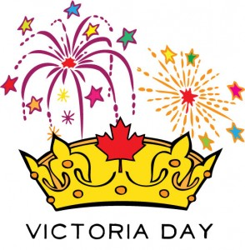 | Raz Kids  Listen, Read, questions  new story | Raz Kids  Record, write Reflection  of same story | Proof Reading  See Assignments | Tumble Books  Library
 | Spelling  See FILES in team under your grade. | Writing  In Teams Class Notebook go to the journal tab to make your written response to today’s reading. | Spelling  See FILES in team under your grade | Spelling  Grade meetings to mark work and have spelling test
 | Math  See Assignments | Math  Code.Org | Math  See Assignments | Math  See Assignments
 | Music  Mrs. Viekles Blog | Socials  Stsailes Legend of the Sasquatch | Typing  Typing.com | Centers  Symbaloo
 | PE  Dinosaur Stomp | Choices  Choose any game or toy or invent your own | PE  Dance to Bach | Art  Drawing Sunflowers
Week: May 19th – 22nd– Opportunities For Learning

