Spring/Easter Chick Directions

- Print the Chick page and the Eggshell Page
- Colour the chick yellow and then cut it out.
- Colour the egg shell either a plain colour or to look like an Easter Egg. If you want to hang your Chick you have to colour both the front and back of the chick and you need to cut out two egg shells and decorate them. One for the front and one for the back (you can cut out one egg shell and use it as a tracer for the second)
- Glue the egg shell onto the chick
- Colour the triangle nose orange (it’s on the egg shell page in the corner)
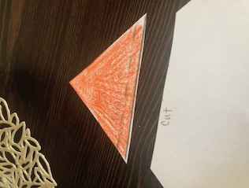
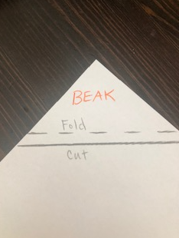
- Cut off the orange triangle
- Fold back the edge, then make a snip in the middle of the folded edge so that you can bend the beak
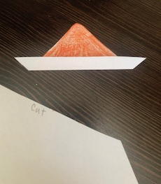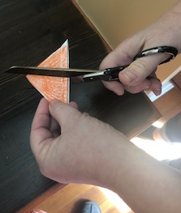

- Put paste on the folded back edge, bend it and glue it onto the Chick

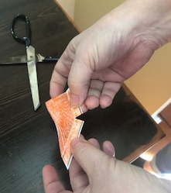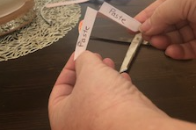

- Voila! you have a little chick hatching from an egg!!! Can you hear it peep?

