How to sign on to your child`s Microsoft account:

- Go to our school website:
https://buckingham.burnabyschools.ca/

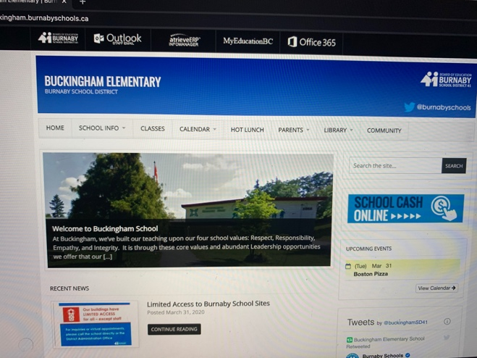
- Click on “Office 365”

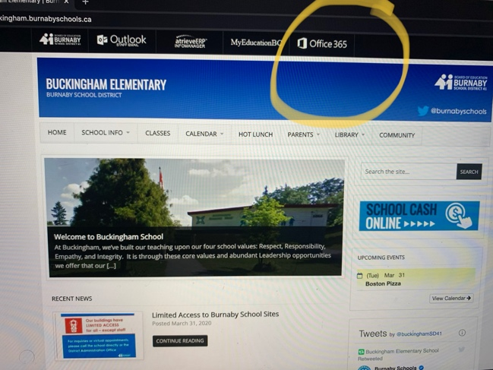

- It will lead you to the sign in page.

Type in your child`s school pin number+ Microsoft address and then press “next”
(example: 12345566@edu.burnabyschools.ca)

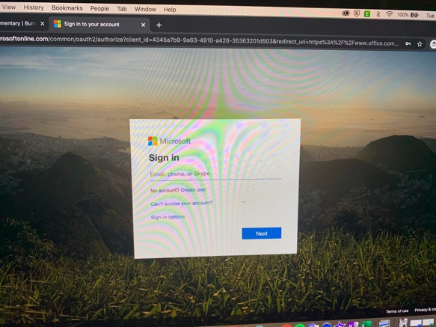

- It will then ask for your child`s password. Type it in and press “sign in”

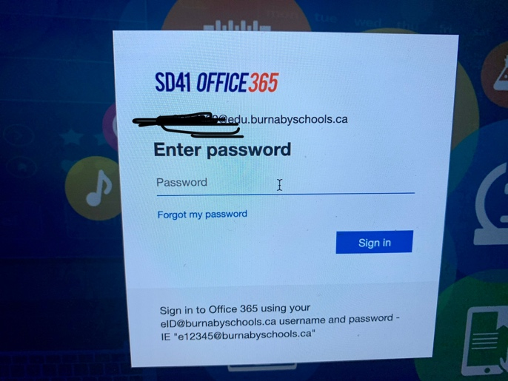

- It will then take you to the Microsoft homepage. Press the arrow to move through some of the homepage`s features.
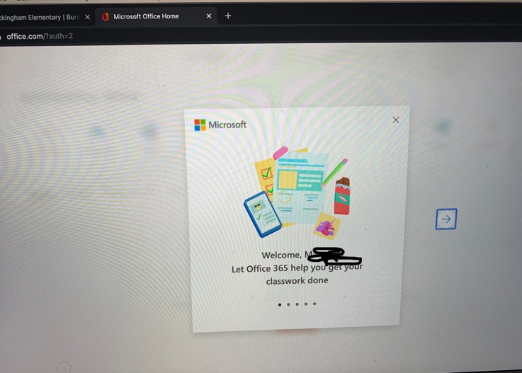

- Once you are on the homepage you can click whatever application you would like to use.
