How to Turn in Work to Assignments on Team

Click on the assignment for the instructions. At the bottom left had side is a
+ sign that says add work – click on those words
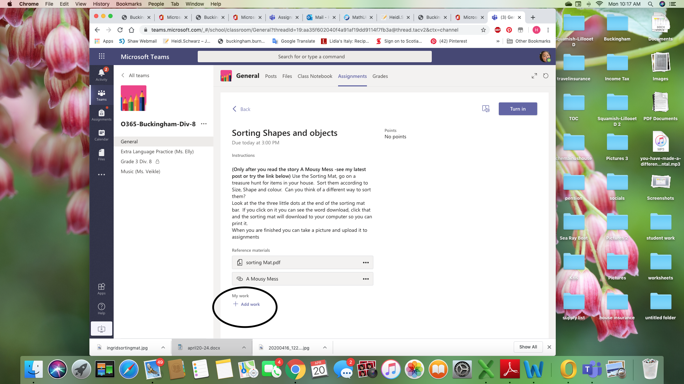

It will open and give you options of 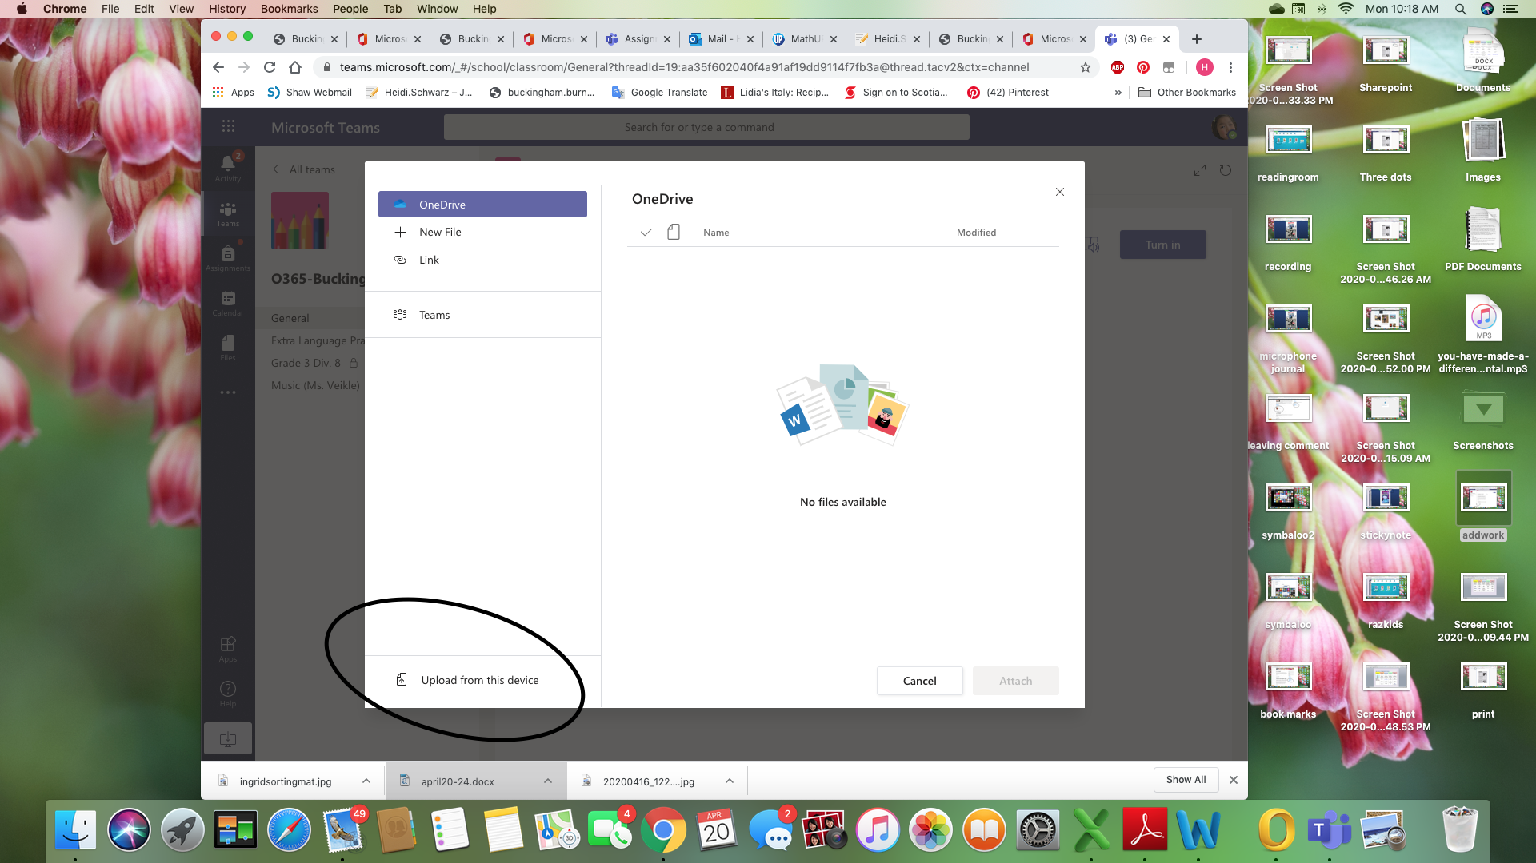where to find the work. Choose Upload from this device
Click on this link and upload the assignment or picture or whatever is required.
Finally Click Done and then in the top right hand corner you will see TURN IN click that and you have turned in the work

