How To Download and Print Spelling Worksheets

- Go to Teams and click on your grade
- Once in grade click on files at the top – NOT ASSIGNMENTS IN GENERAL
- Click on the worksheet. Once the worksheet has opened look for the three dots … and click on them
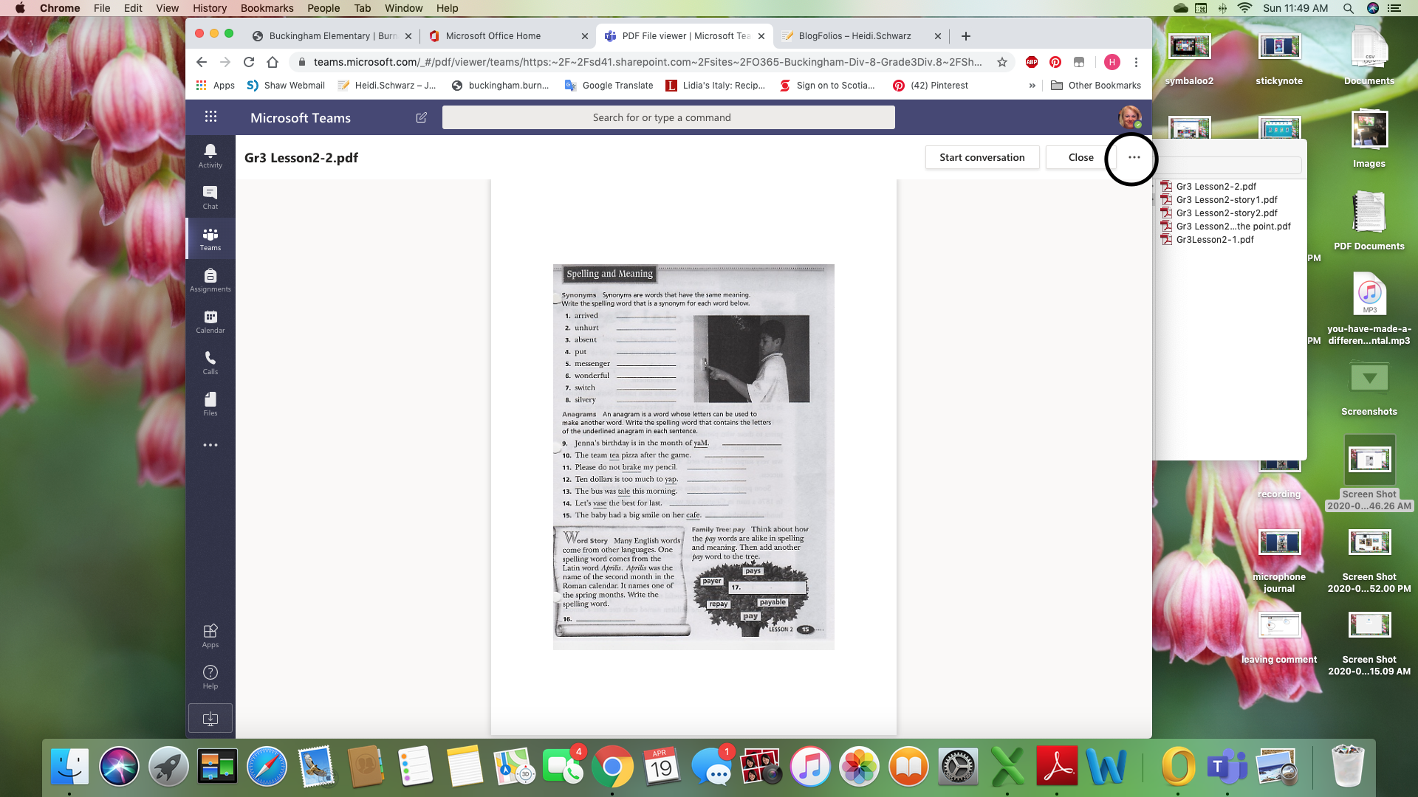

- Once that screen has opened click on Sharepoint

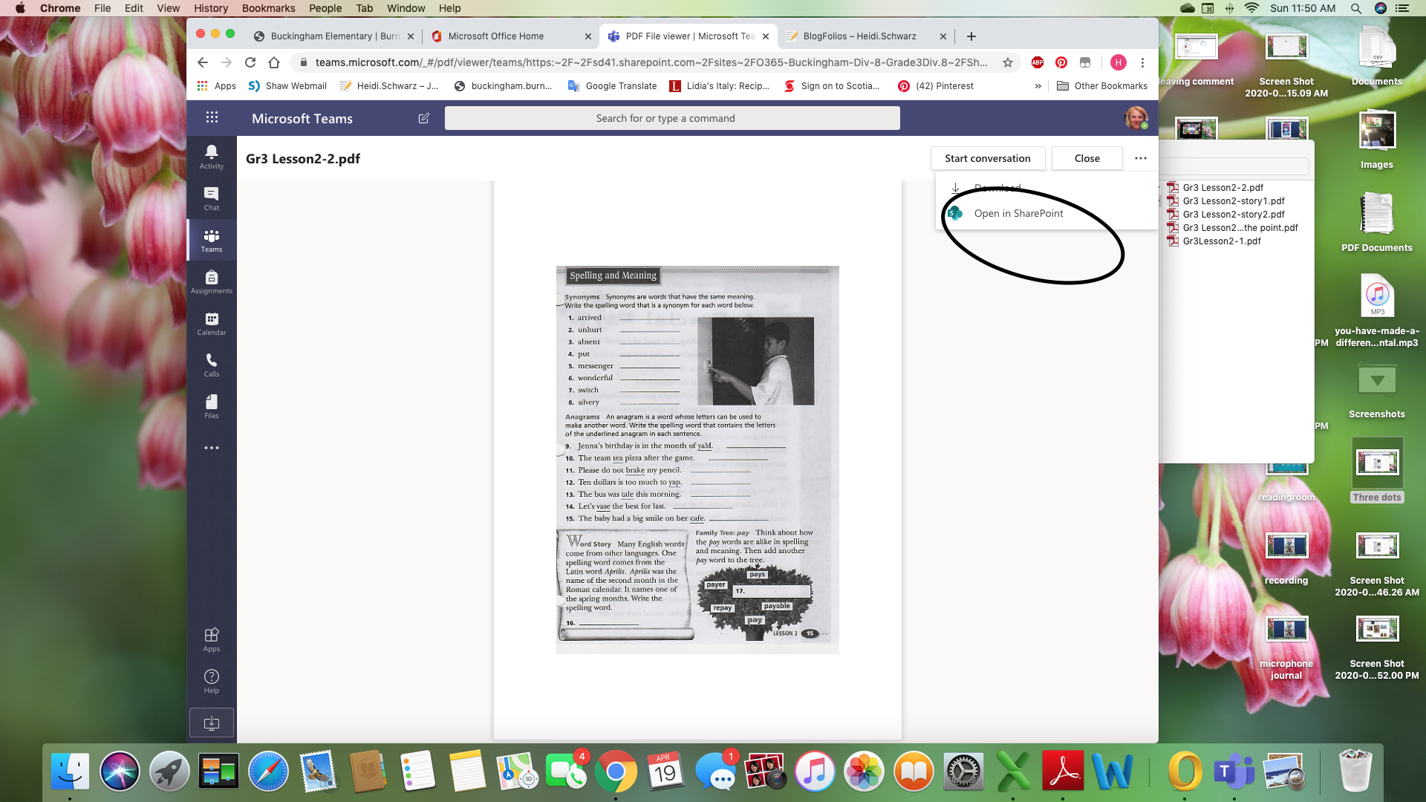
Once you have clicked on Sharepoint look at the top for the print button

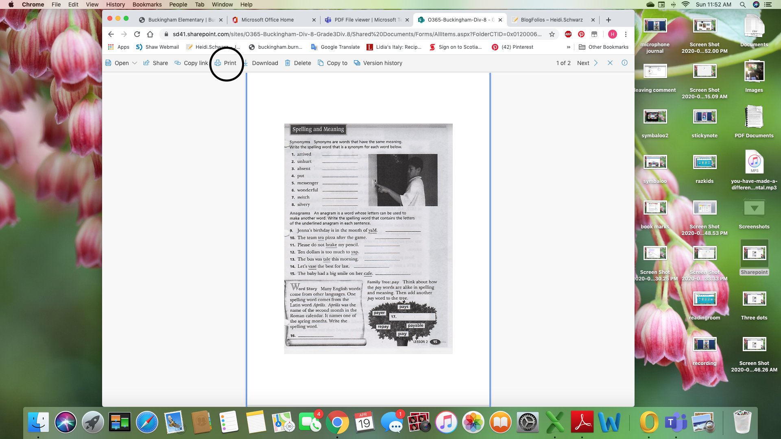
Print off the worksheet so that you can have your spelling words and assignments. I will post spelling sheets every Monday and Wednesday. They will always be in your grade Team under Files.
Don’t LOOSE THEM!!! On Friday we will go over the answers together and I will give you a spelling test. You do not have to send them to me

