Name: _________________________

**Multiplication with Arrays**

When you multiply, think of the multiplication symbol as having the

meaning “rows of.”

The fact 3 x 6 would actually mean “3 rows of 6.”

To solve this fact, draw 3 rows of 6 symbols.

x x x x x x

x x x x x x

3

rows of 6 symbols equals 18 symbols.

x x x x x x

3

18

x 6 =

Symbols arranged in neat rows and columns are called arrays.

Look at each array. Count the symbols in each row and column carefully.

Write the multiplication fact for each.

**1.**

O O O O O O O O

O O O O O O O O

_______ rows of _______ equals _______

O O O O O O O O

O O O O O O O O

_______ x _______ = _______

**2.**

| | | | | | | | |

| | | | | | | | |

_______ rows of _______ equals _______

| | | | | | | | |

| | | | | | | | |

_______ x _______ = _______

| | | | | | | | |

**3.**

◆

◆  

◆   

_______ rows of _______ equals _______

◆   

◆   

_______ x _______ = _______

***Now try this:***

On the back of this paper, draw an array for each of these facts:

***x 4***

***7***

***8***

***x***

***3***

***9***

***x***

***6***

***3***

***x***

***7***

***8***

***x***

***5***

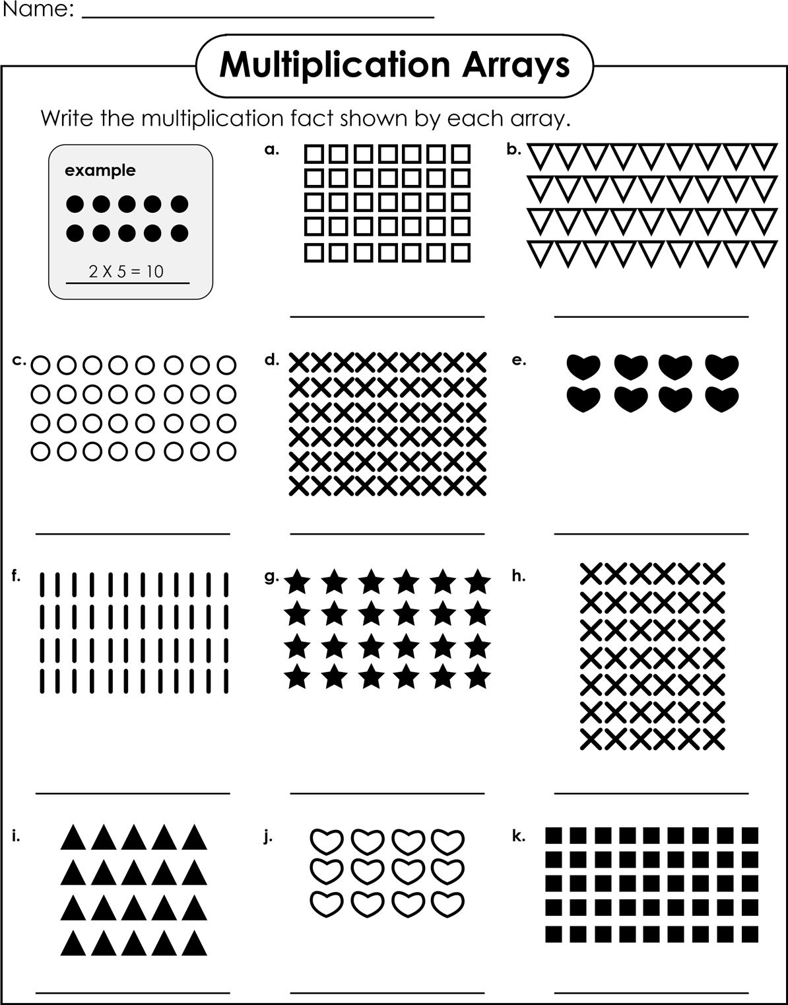

Name: _________________________

**Multiplication with Arrays**

You can find the answer to basic multiplication facts by making a symbol

picture called an array.

An array is a group of symbols arranged in straight rows and columns.

x x x x x x x

x x x x x x x

3 rows of 7 symbols equals 21 symbols.

x x x x x x x

3 x 7 = 21

Draw an array to find the answer to each multiplication fact below.

Be sure you draw your symbols in neat, straight rows and columns.

4

x 5 = ______

6

x 4 =

______

3

x 8 = ______

3

x 9 = ______

5

x 8 = ______

7

x 4 = ______

4

x 9 = ______

5

x 5 = ______