Name: _________________________ Subtraction: 2-digit minus 2-digit (Borrowing)
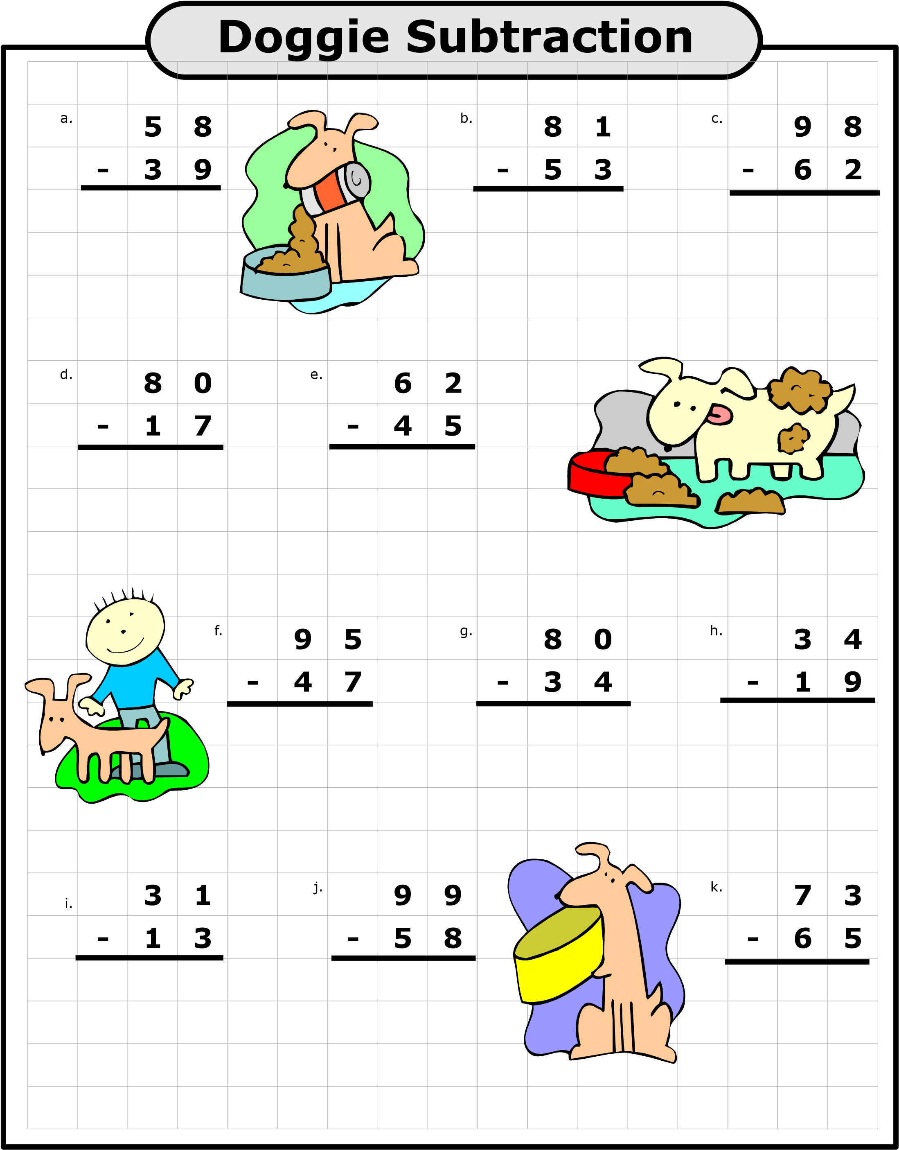
Super Teacher Worksheets - www.superteacherworksheets.com

