Name: _____________________________________________ Addition: 2-Digit Addends

a. |  | 7 | 9 |  |  | b. |  | 2 | 7 |  |  | c. |  | 4 | 5
 | + | 1 | 6 |  |  |  | + | 3 | 4 |  |  |  | + | 9 | 5
d. |  | 5 | 6 |  |  | e. |  | 3 | 4 |  |  | f. |  | 1 | 2
 | + | 6 | 3 |  |  |  | + | 4 | 4 |  |  |  | + | 8 | 5
g. |  | 4 | 6 |  |  | h. |  | 5 | 6 |  |  | i. |  | 5 | 0
 | + | 3 | 9 |  |  |  | + | 2 | 9 |  |  |  | + | 3 | 8
j. |  | 5 | 8 |  |  | k. |  | 7 | 3 |  |  | l. |  | 9 | 4
 | + | 9 | 1 |  |  |  | + | 1 | 7 |  |  |  | + | 2 | 0
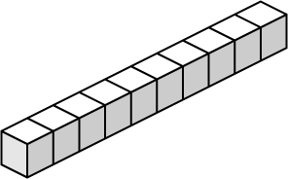
Name:
Addition Blocks
6
4
1
8
+
1
9
7
3
+
2
0
4
5
+
3
9
5
6
+
4
6
2
5
+
8
4
1
5
+
5
9
2
8
+
7
0
1
4
+
3
5
2
6
+
Use place value blocks to add. Trade ones for tens.
Worksheet 1
a.
b.
c.
d.
e.
f.
g.
h.
i.
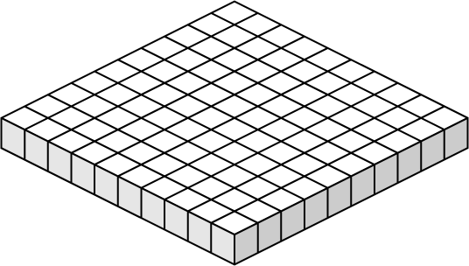
Name:
Addition Blocks
5
5
2
9
+
3
6
5
9
+
8
4
6
1
+
4
8
1
7
+
7
9
3
7
+
2
4
6
5
+
9
3
5
8
+
6
0
3
2
+
7
6
2
6
+
Use place value blocks to add. Trade ones for tens and tens for hundreds.
Worksheet 2
a.
b.
c.
d.
e.
f.
g.
h.
i.

