My Province or Territory Report

Draw a large map of your province or territory.

Geography
Which Canadian provinces and territories border your province or territory?

If your province or territory borders the United States, which states border it?

Write the names of any large bodies of water that border your province or territory.
.

Major Cities & Capital City
The capital of my province or territory is and it has a population of .

Other major cities in my province or territory include ,
, and .

Symbols
Here’s a picture of my province’s or territory’s flag:

Here’s a picture of my province’s or territory’s coat of arms:

People, Natural Resources, and Industries
Use the chart below to list famous people from your province or territory and their accomplishments.
 | Famous Person | Why This Person Is Famous
1.
2.

Natural Resources and Industries
A natural resource is something that is found in nature that is useful to humans. Trees, coal, gold, and oil are all examples of natural resources.
Some natural resources that are harvested in my province or territory include
.
An industry is how people make money by selling goods and services. Farming, mining, fishing, and manufacturing are a few examples of industries.
Some important industries found in my province or territory include
.

Attractions
If you visit , you should really see these attractions! (name of your province or territory)
Attraction #1:
Description of attraction #1:

Attraction #2:
Description of attraction #2:

Draw a picture of attraction #1. |  | Draw a picture of attraction #2.

Colour your province or territory red. Colour all other provinces or territories green.
Map
Province or Territory:
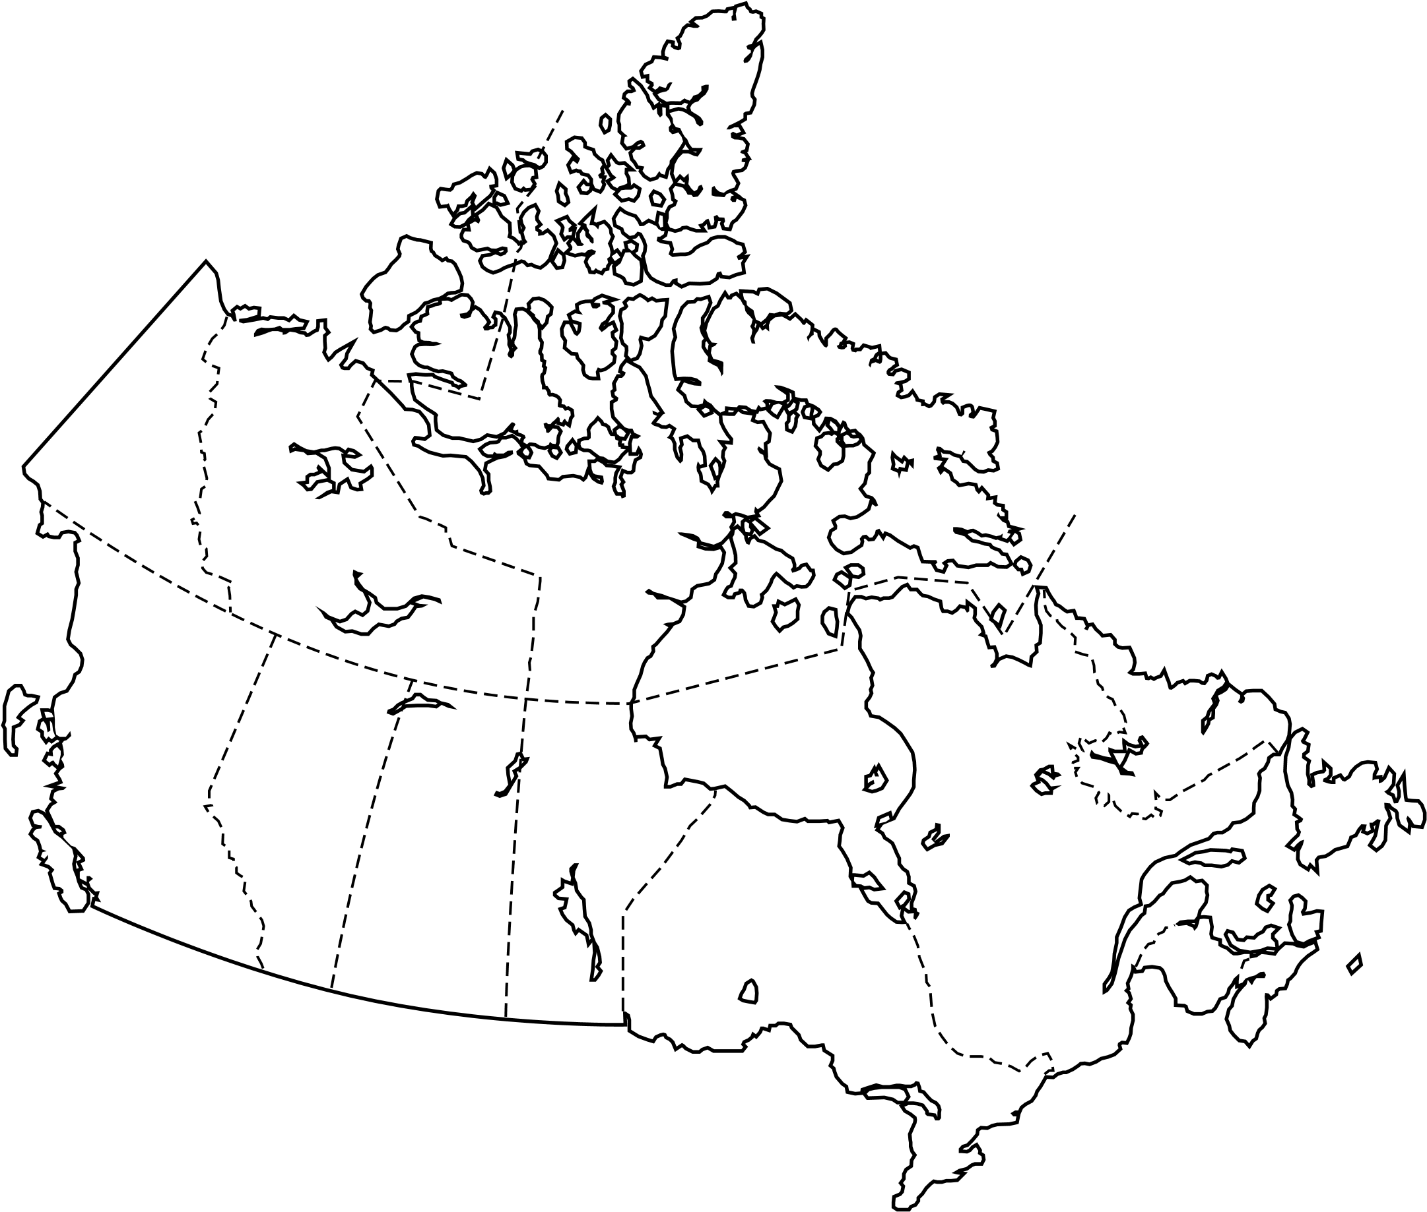
The population of is .
(name of your province or territory) (population)
The total land area of this province or territory is .
(total area - don’t forget to write “sq. km” after the number)
Here are five interesting facts about my province or territory.
1.

2.
Interesting Facts
Province or Territory:

3.

4.

5.

List the books and websites where you found your information.
When you list a book, include the author’s name and the title of the book.
When you list a website, list the url and a title of the article.
1.

2.
Bibliography
Province or Territory:

3.

4.

5.

