Name:

Canadian Coins

**Counting Money**

2

Dollars

Count the coins and write the amounts.

The Canadian 2 dollar coin, or

toonie

, is worth $2.00

front

back

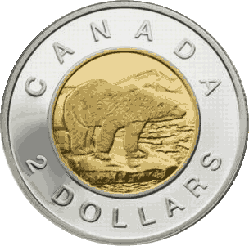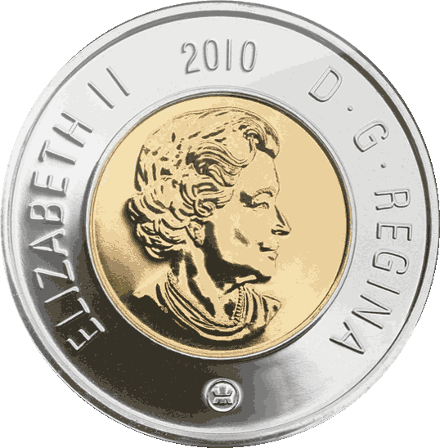

$

**6.00**



$



$



$



$



$



$

