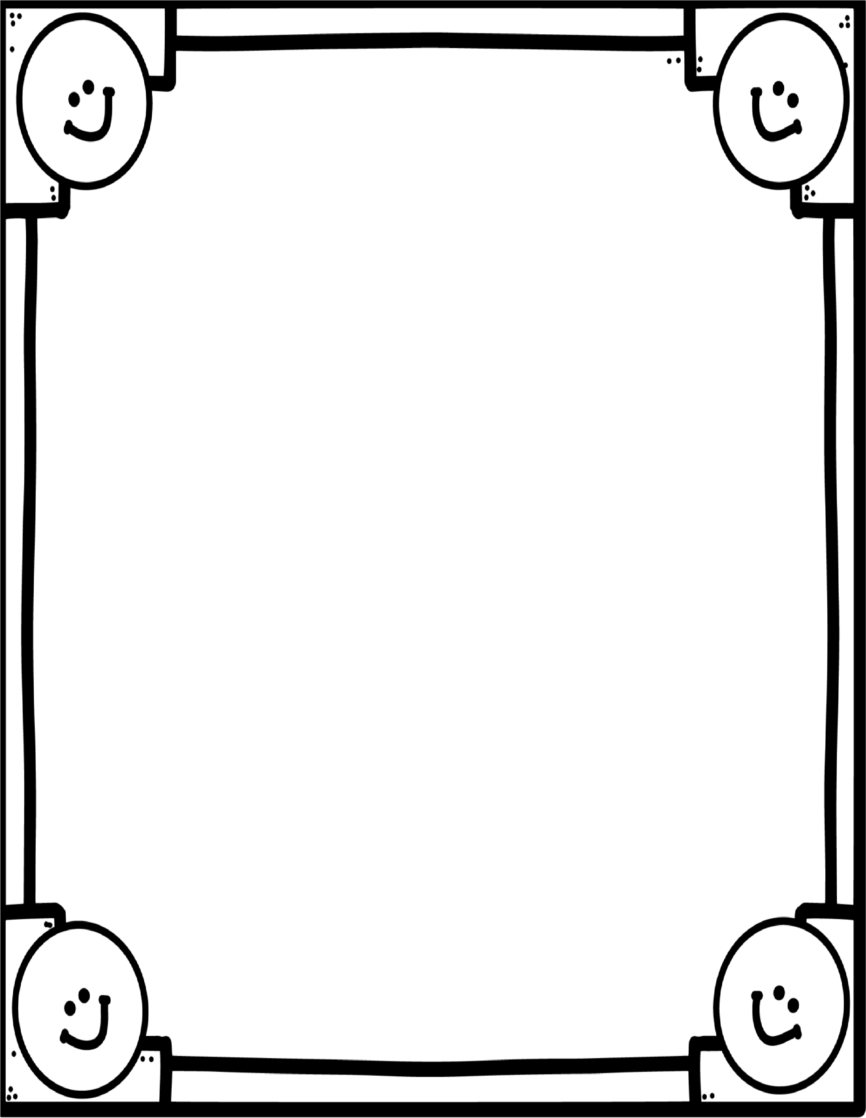

**T**

**WO DIGIT**

**M**

**IXED**

**–**

**NO**

**REGROUPING**

**How Do You Make Time Fly?**

___ ___ ____ ____ ____ _____ ____ _____ _____

_____ ____

52

99

69 12 15 32 44 31 12 44

49

____ ___ ____

____ ____ ____

_____ ____ ____ ____ ___

_

__

12

5

9

52 52

9

9

35

43 86

15

59

12

15

A

55

-

23

H

78

+21

W

69

-

54

R

43

+26

C

88

-

44

U

34

+25

T

64

-

12

S

56

+23

O

83

-

71

D

47

+12

L

59

-

28

K

23

+26

E

98

-

73

N

21

+65

I

67

-

24

