Staple Here
Father’s Day
Coupon Book
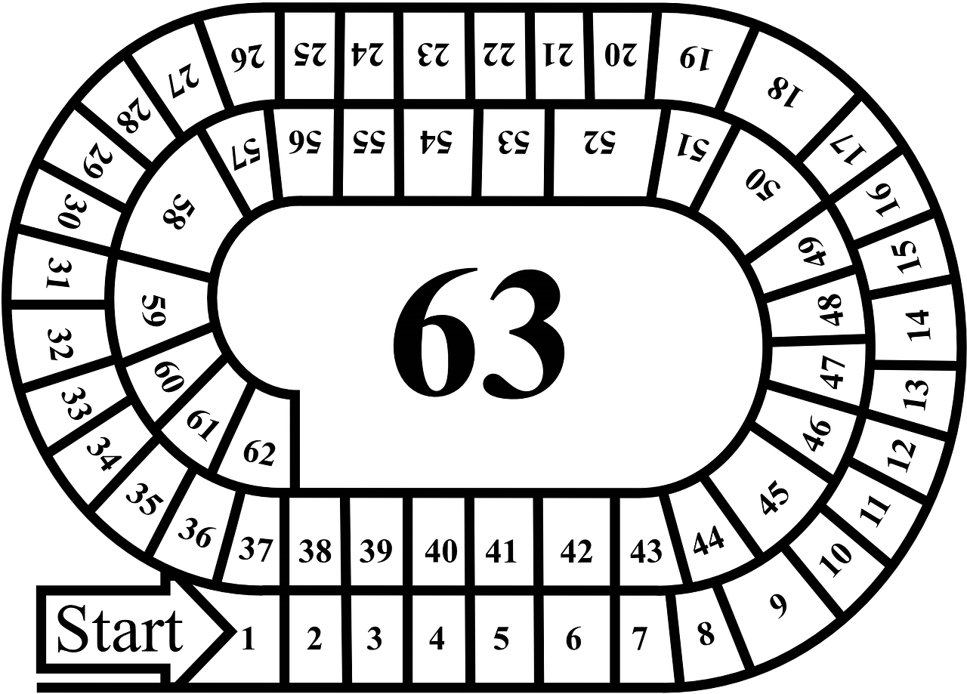
This coupon is for a game of your choice!
This coupon is for a big hug!
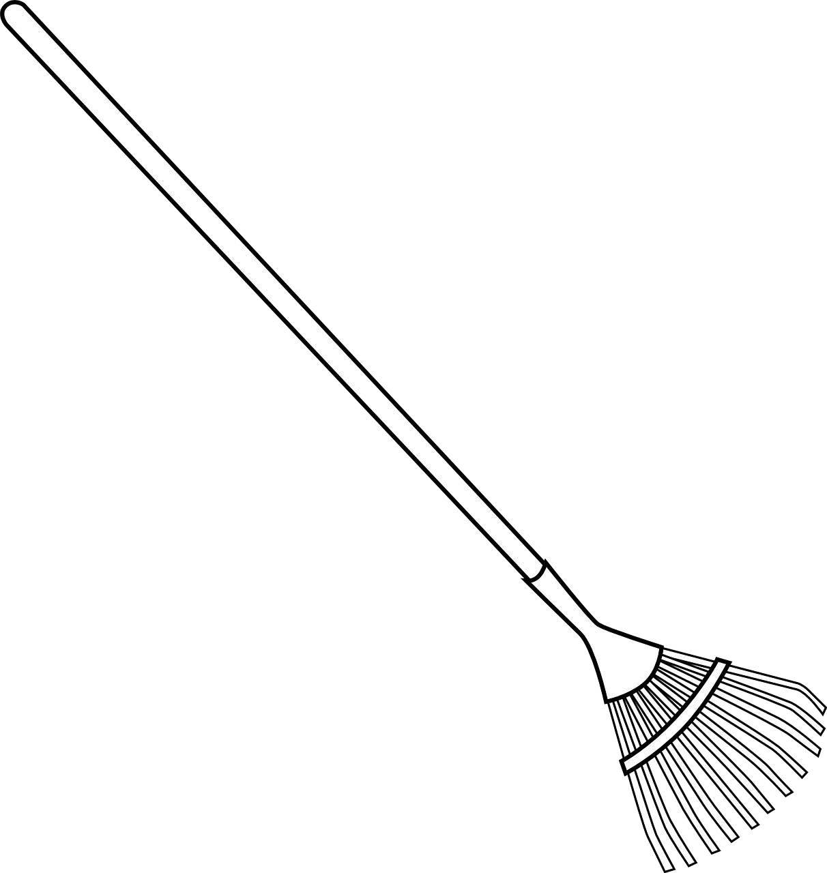
This coupon is for some help with yard work!

This coupon is for eating lunch together!
This coupon is for a movie night together!
This coupon is for help washing the car or truck!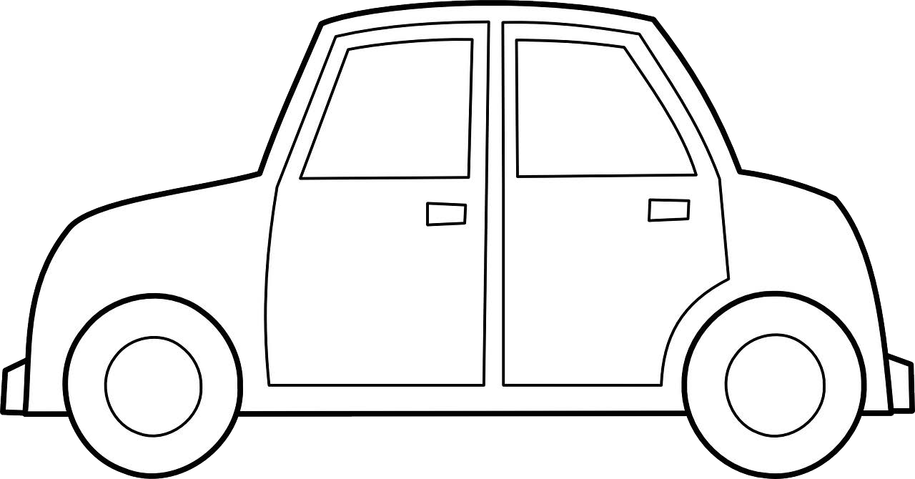
This coupon is for going for a walk together!

This coupon is for eating my vegetables!
This coupon is for cleaning
my room with no complaining!
This coupon is for help washing the dishes!
This coupon is for going to the park together! 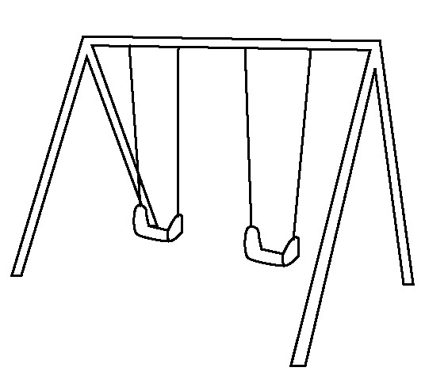

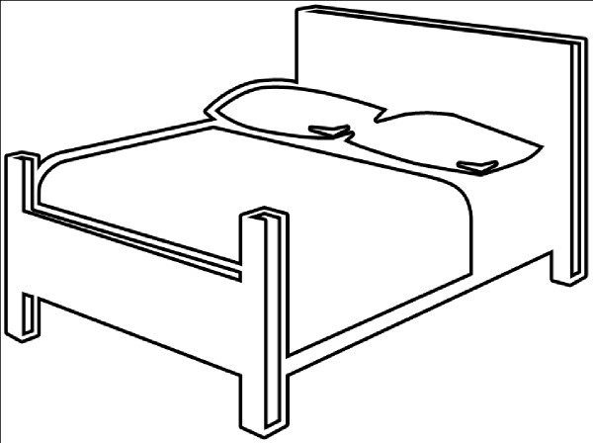
This coupon is for breakfast in bed!
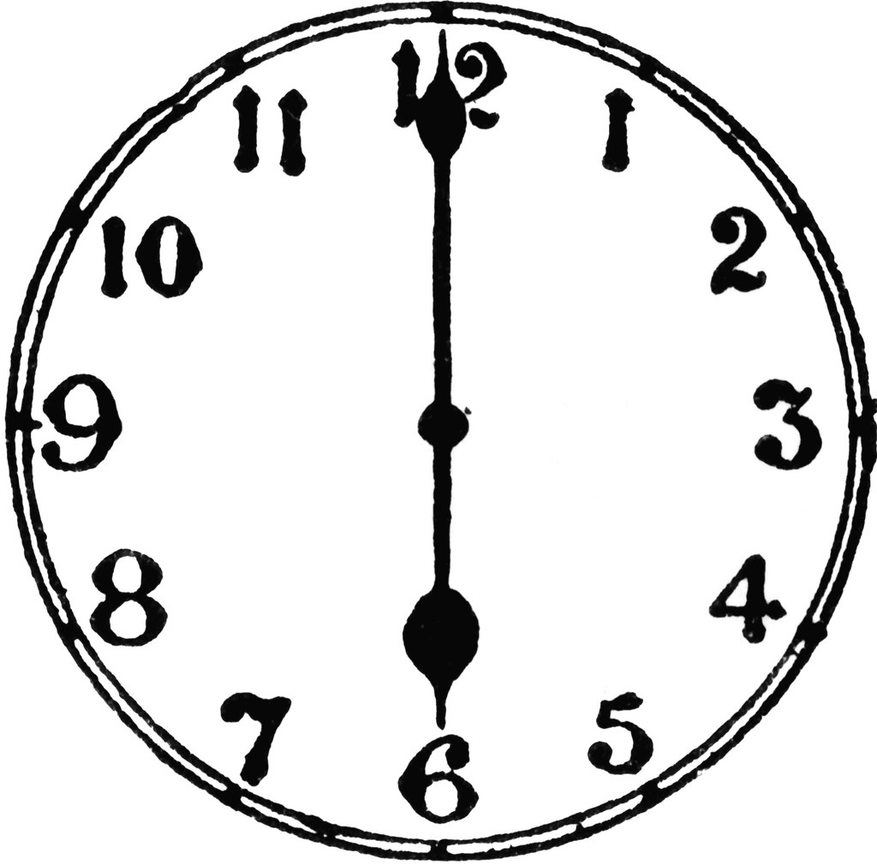
This coupon is for an hour of quiet time!
This coupon is for help walking the dog!
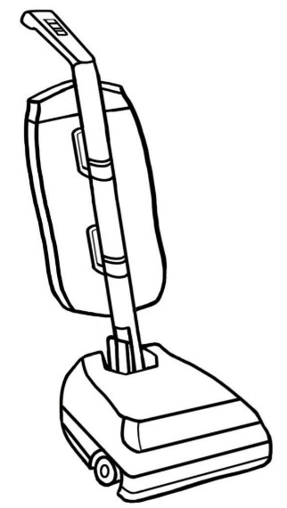
This coupon is for vacuuming the house!

This coupon is for taking out the trash! 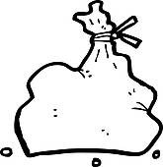
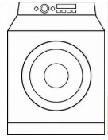
This coupon is for help with laundry!
This coupon is for help feeding our animals!
This coupon is for help carrying the groceries!

