Name: ______________ Student Self-Assessment
Core Competencies
Read each statement below. Circle one of J K L Take your time.
PERSONAL / SOCIAL 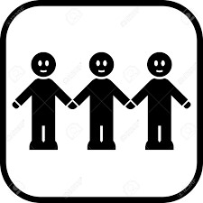
J K L | I am kind, I can show respect, kindness and support to others.
J K L | I can solve problems in a peaceful way and ask for help when I need it.
J K L | I can participate in activities to improve the classroom, school, community or natural world.
J K L | I can describe who I am and my positive qualities and strengths.
J K L | I can tell you about the people, places and things that are important to me.
J K L | I can describe my family and community.
J K L | I can make choices that keep me happy, healthy and safe.
J K L | I can use strategies to manage my emotions.
COMMUNICATION
J K L | I can listen to others.
J K L | I can share my ideas and questions.
J K L | I can work together during group activities.
J K L | I can reflect on my learning.
CRITICAL THINKING 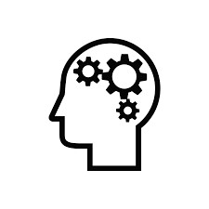
J K L | I can get ideas when I explore and ask questions.
J K L | I can try different ways of doing things.
CREATIVE THINKING
J K L | I can get ideas (by exploring and play) and build on other’s ideas to create new things.
J K L | I can try a new idea when something doesn’t work; sometimes it takes a few tries.

