Name: 3-Digit Subtraction with Zero
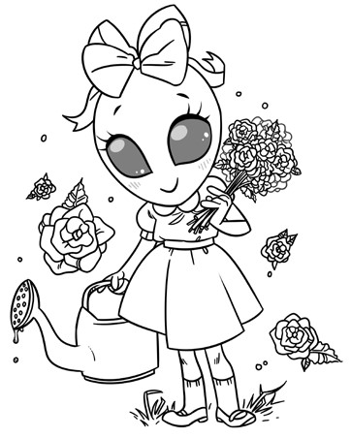
Garden Alien
Subtract to find the differences.
Then match the letters to the
blanks below to solve the riddle.
101
-
14
E
100
-

49
R
300
-106
E
506
-239
E
204
-128
W
723
-604
O
705
- 229
K
602
-
317
O
900
-
9
E
200
-
74
D
600
-186
T
405
-189
A
508
- 309
M
706
-
347
T
307
-
89
Y
700

-
23
E
400
-
188
R
901
-

86
U
What did the alien say to the flower in the garden?

414 216 476 87 199 891

359 119 218 285 815 212

76 194 267 126 677 51

