Name: Subtraction (no regrouping)
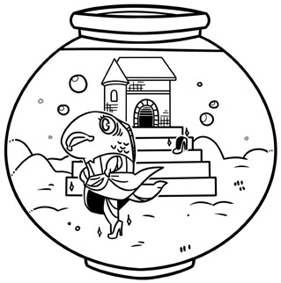
Fairy Tale Subtraction
Subtract to find the differences.
Then match the letters to the
blanks below to solve the riddle.
321
-210
A
745
-324
L
745
-
25
S
828
-
516
P
935
-
723
P
723
-
13
G
586
-
63
L
923
-
123
R
769
-
455
S
886
-
365
F
567
-
366
E
789
-
135
S
544
-
503
T
What did Cinderella fish wear to underwater ball?

710 421 111 720 314

521 523 41 312 212 201 800 654

