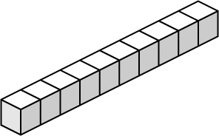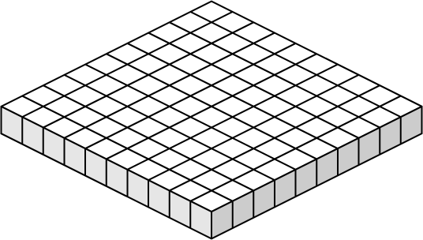
Name:
Subtraction Blocks
3
4
6
1
8
5
-
9
2
2
4
5
6
-
5
3
4
3
5
7
-
7
0
3
4
1
2
-
6
8
1
3
7
9
-
2
9
6
1
7
9
-
8
5
8
5
6
9
-
4
1
6
2
7
1
-
6
2
0
1
8
9
-
Use place value blocks to subtract. Trade hundreds for tens and tens for ones.
Worksheet 1
a.
b.
c.
d.
e.
f.
g.
h.
i.
Super Teacher Worksheets - www.superteacherworksheets.com
Name:
Subtraction Blocks
4
9
1
2
6
8
-
7
2
5
3
5
9
-
8
0
7
1
5
0
-
6
4
2
4
3
6
-
3
9
4
1
2
6
-
9
4
7
3
8
8
-
8
1
7
2
5
4
-
5
4
0
4
3
6
-
6
7
1
1
9
1
-
Use place value blocks to subtract. Trade hundreds for tens and tens for ones.
Worksheet 2
a.
b.
c.
d.
e.
f.
g.
h.
i.
Super Teacher Worksheets - www.superteacherworksheets.com

