Name: 3-Digit Addition (regrouping)
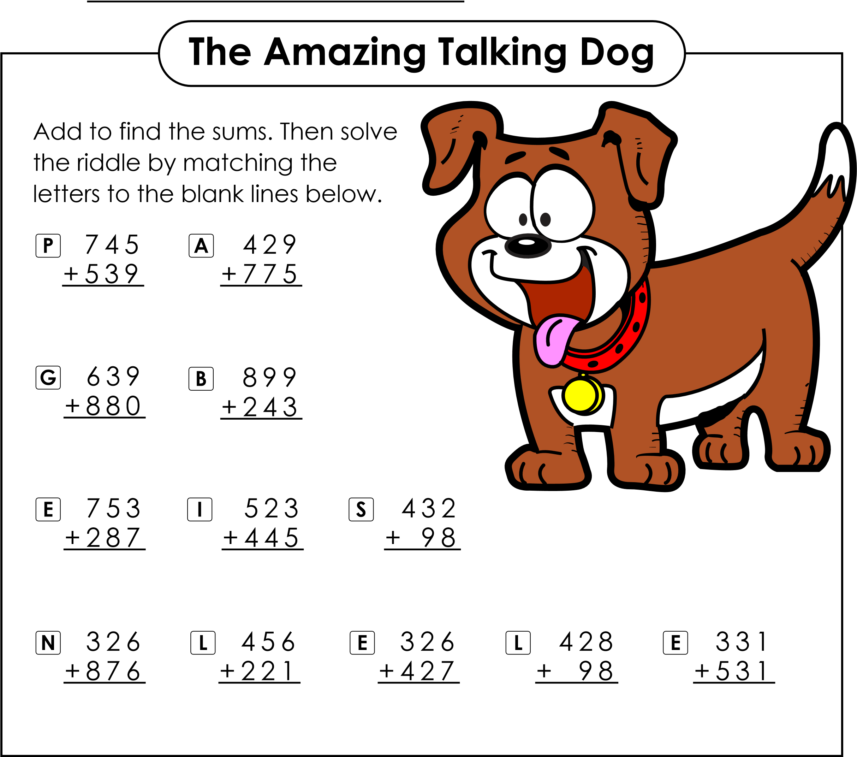
What is even more amazing than a talking dog?

1,204 530 1,284 1,040 526 677 968 1,202 1,519

1,142 753 862

