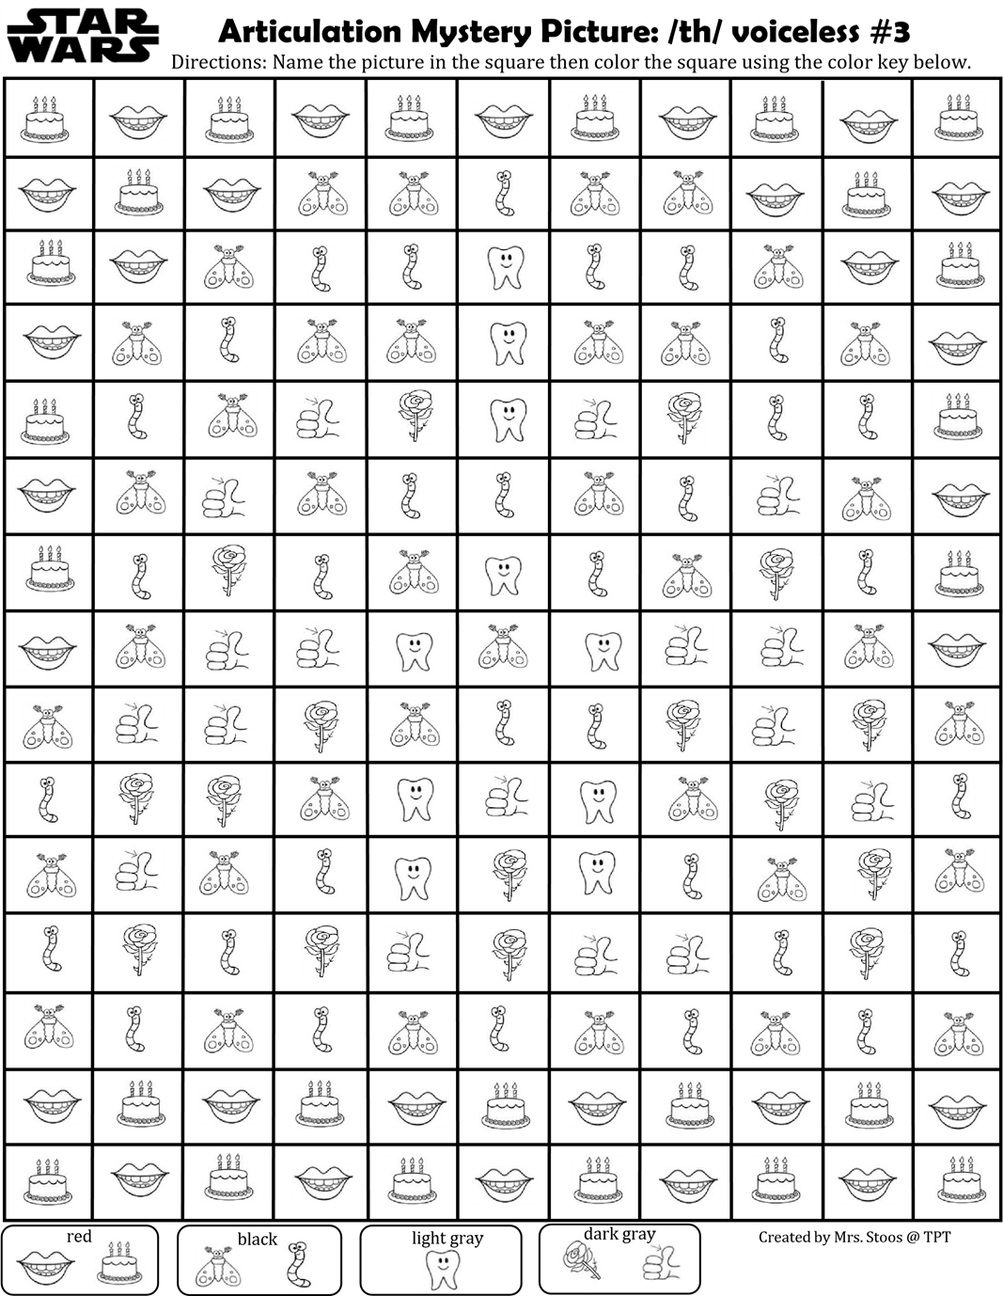
Word list: mouth, birthday, moth, earthworm, tooth, thorn, and thumb.

