Name: 3-Digit Addition (no regrouping)
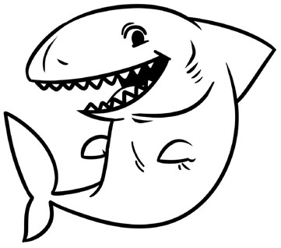
Addition Shark Attack
Add to find the sums. Then solve
the riddle by matching the letters
to the blank lines below.
321
+122
A
561
+128
S
943
+
36
L
453
+543
W
334
+621
D
509
+220
W
741
+245
L
621
+176
E
321
+623
L
532
+326
E
534
+415
A
400

+
54
T
820
+

64
H
686
+113
E
143
+223
R
330
+634
O
What is a shark’s favorite game?  689 729 949 979 986 964 996  454 884 797 944 858 443 | 955 | 799 | 366

