3d solid detective
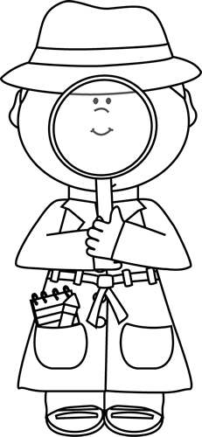
Directions: Write the number of faces, edges and vertices for each 3D shape shown.
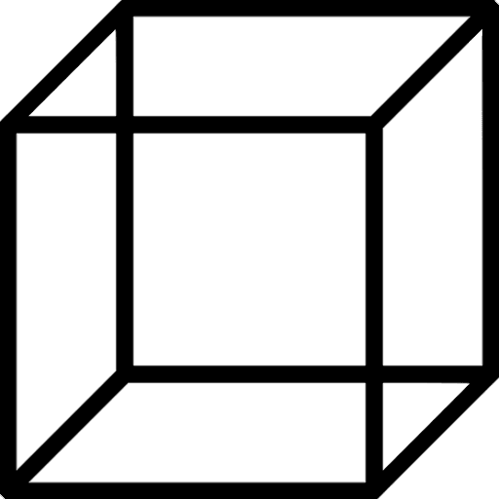

Faces:  Edges:  Vertices: | Faces:  Edges:  Vertices: | Faces:  Edges:  Vertices:
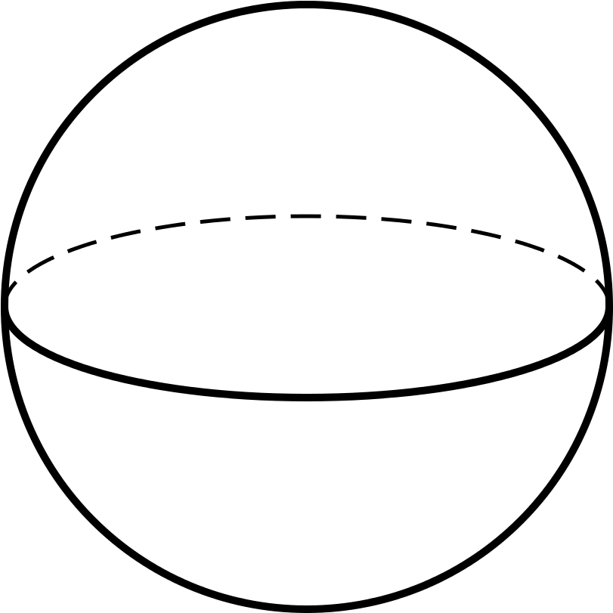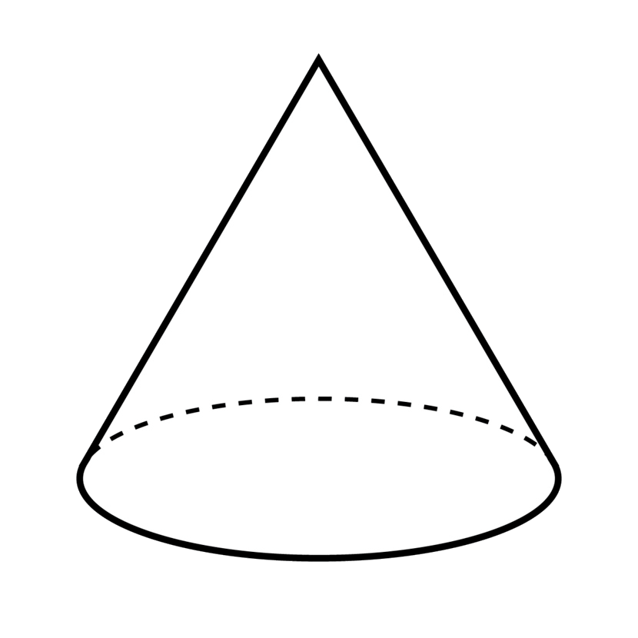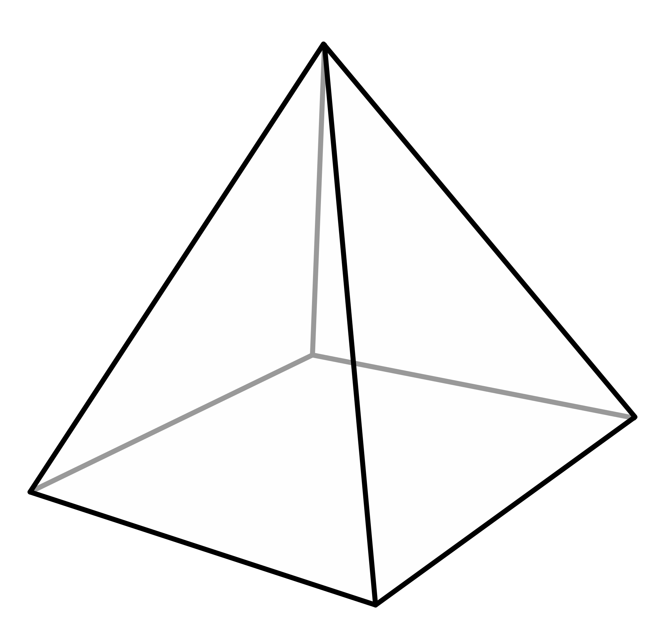
Faces:  Edges:  Vertices: | Faces:  Edges:  Vertices: | Faces:  Edges:  Vertices:

Matching 3d-shapes
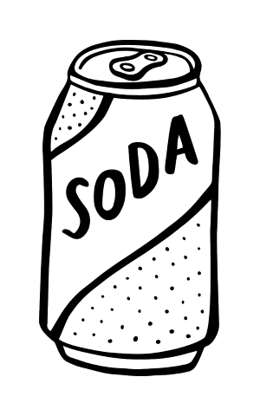
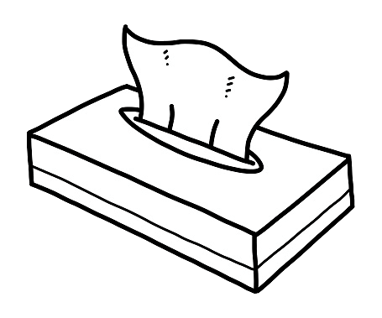
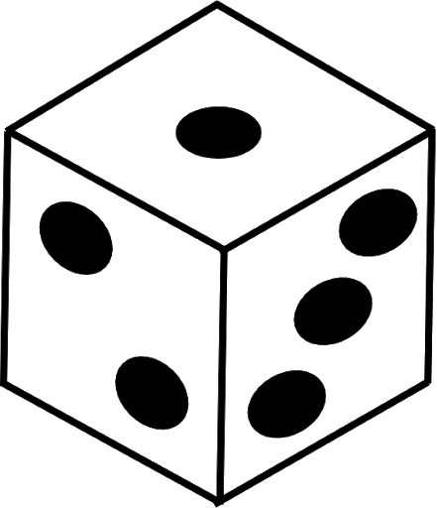
Directions: Circle the correct 3D-Shape name of each object.

Cube Rectangular Prism Cylinder

Sphere Cube Sphere Cone Cylinder Cone

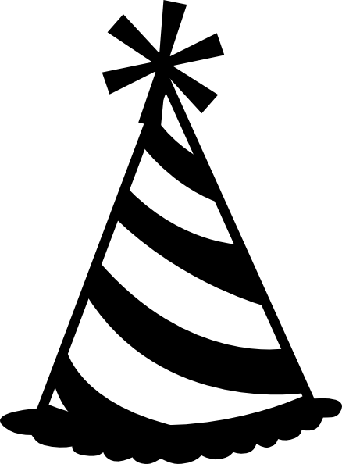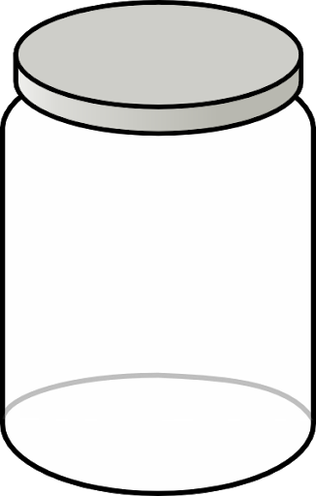
Sphere  Cone  Triangular Prism | Cone  Cylinder  Sphere | Cone  Cube  Cylinder
what shape am I?

Cube

Rectangular Prism

Cylinder

Sphere

© 2020 The Teachers Corner Blog.

