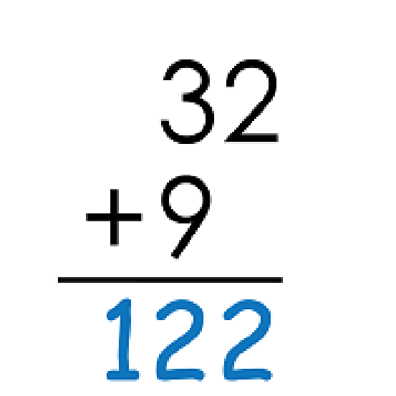

Name: ____________________________________

Skill: Addition with 2-Digit Addends

**Find the Mistakes**

**a.**

There is a mistake in the way this math

problem was solved.

Solve the math problem correctly.

Explain the error. _____________________________________________________________________

_____________________________________________________________________________________

_____________________________________________________________________________________

**b.**

There is a mistake in the way this math

problem was solved.

Solve the math problem correctly.

Explain the error. _____________________________________________________________________

_____________________________________________________________________________________

_____________________________________________________________________________________

